**A**

**PROJECT REPORT**

**On**

**City Clave**

**At TECHPILE TECHNOLOGY PVT. LTD., LUCKNOW**



**Submitted Towards Partial Fulfillment of**

**Three-Year Diploma in**

# Information Technology

**Under the supervision of**

**Rahul Soni**

**SUBMITTED TO: SUBMITTED BY:**

**SANDEEP KUMAR SABA AZIM**

**Government Polytechnic Lucknow**

**Session 2024-2025**

**Enroll: Techpile-ST240032**

**COMPLETION CERTIFICATE**

This is to certify that **Ms. Saba Azim** of **DIPLOMA (Information Technology)** from **Government Polytechnic Lucknow** (Institute/University) was working on the project entitled “**City Clave**” developed on **"Python with Django"** in Techpile Technology Pvt. Ltd. She was engaged with us during **15 August** to **30 September** for a period of **45 days.**

She has done an excellent job during her engagement with the Software Development & Testing Division of the company. She has completed her project during the training tenure. Her performance has been good and satisfactory.

I would like to take this opportunity to express my appreciation to **Ms**. **Saba Azim** for her work and wish her all the very best for her future endeavors.

**Regards,**

**Divya Rai**

**Project Manager**

**Techpile Technology Pvt. Ltd.**

**Lucknow (U.P.) Signature**

# PREFACE

Summer training is an important part of the engineering curriculum. The Diploma course summer training helps a student in getting acquainted with the manner in which her knowledge is being practically used outside her institute and this is normally different from what she has learnt from books. Hence, when the student switches from the process of learning to that of implementing her knowledge, she finds an abrupt change. This is exactly why summer training session during the Diploma curriculum becomes all the more important. Summer training is prescribed for the student of Technical College as a part of the Three-year degree course of engineering by the BTEUP. We are required to undergo summer training for a period of 45 days after the completion of the 3rdyear.

This training report describes in detail the training after the 2nd year session, which I completed at the ***Techpile Technology Pvt. Ltd...*** This report also gives the information about the organization and it’s working along with the project undertaken in the training period.

The fundamental step used in **SDLC** process is based on the ISO 9001 guidelines. My aim was to follow the ISO guidelines and develop a perfect system.

The system development was organized into 5 major parts:

1. **Requirement Gathering**
2. **Documentation/Design**
3. **Development**
4. **Coding**
5. **Testing**

**ACKNOWLEDGEMENT**

Apart from my effort, the success of the project depends largely on the encouragement and guidelines of many others. We take this opportunity to express our gratitude to the people who express have been instrumental in the successful completion of this project.

I would like to express my deep and sincere gratitude to my supervisor Mr. **Rahul Soni** Sir **(**Techpile Technology Pvt. Ltd.) who gave me his full support and encouraged me to work in an innovative and challenging project for educational field. His wide knowledge and logical thinking gave me right direction all the time.

I am deeply grateful my project coordinator for his help and support provided at every step of the project.

Last but not the least, I thank to all employees of **Techpile Technology Pvt. Ltd...** for their support and co-operation.

***Saba Azim***

**DECLARATION**

This is to certify that the project report entitled “**City Clave**” is done by me is an authentic work carried out for the partial fulfillment of the requirements for the award of Diploma in **“(Information Technology)”** under the guidance of **Mr.** **Rahul Soni**. The matter embodied in this project work has not been submitted earlier for award of any degree or diploma to the best of my knowledge and belief.

**Saba Azim**

**INDEX**

**PAGE**

1. **Introduction……………………………………………………………………..…10-13**
   1. Overview of Organization……………………………………………………….…..……...10-11
   2. Introduction………………………………………………………………………..…….….11-11
   3. Objectives…………………………………………………………………………..…….....11-12
   4. Problem Definition…………………………………………………………………..……...12-13
2. **System Analysis……………………………………………………………………14-24**
   1. Objective……………………………………………………………………………………14-14
   2. SDLC Phases…………………………………………………………………………..…...14-18
      1. Preliminary Investigation…………………………………………………………...…….14-16
      2. System Analysis……………………………………………………………………..……16-16
      3. System Design……………………………………………………… ……………..……..16-16
      4. Coding……………………………………………………………………………..….…...16-16
      5. Testing…………………………………………………………………………………...17-17
      6. Implementation……………………………………………………………………….….17-17
      7. Maintenance……………………………………………………………………………..17-17
   3. Process Description………………………………………………………………..………..19-19
   4. Project Model Used……………………………………………………………………..…..19-20
   5. ER-Diagram………………………………………………….……………………………..21-22
   6. Data Flow Diagram…………………………………………….…………………………...22-24
3. **Software Hardware Requirement Specification……………….……………25-27**
   1. Hardware Requirement……………………………………………….….………………....25-25
   2. Software Requirement…………………………………………………..……….………….25-26
   3. Support Maintenance…………………………………………………………….…………27-27
4. **System Design Approach…………………………………………………………27-28**
   1. Top-Down Designing…………………………………………………….……….….…….27-27
   2. Bottom –Up Designing…………………………………………………….….…..………..28-28
   3. Following Approach……………………………………………………….. ……...………28-28
5. **Backend Design……………………………………………….…...........................28-34**
   1. Description of Classes and Methods (model.py)………………………………………..….28-29
   2. Defined urls (urls.py) …………………………………………………………………...….29-34
6. **Data Modeling………………………………………………………….………….34-38**
   1. List of Tables………………………………………………………………...……………...34-35
   2. Structure of Tables……………………………………………………….………………....35-38
7. **Testing…………………………………………………………...………………....39-43**
8. **Input-Output Forms…………………………………………..…………………..43-61**
   1. Project Screenshot………………………………………………………………………..…..43-50
   2. Project Coding…………………………………………………………………………….… 50-61
9. **Future Scope…………………………………………………...…………………61-72**
10. **Conclusion……………………………………………………...……………….72-72**

**LIST OF TABLES**

**PAGE**

1. Category Table ………………………………………………………….…………..35
2. Contactus Table………………………………………...………….…………….…..36
3. Service_provider Table………………………………………………………...….…37
4. Tbl_register Table……………………………………………...……………….……38
5. Tbl_slides Table……………………………………………...………………………34

**LIST OF FIGURES**

**PAGE**

1. SOFTWARE DEVELOPMENT LIFE CYCLE ….…………………………..…..…..….……...…...18
2. DEVELOPMENT PHASE……………………….……………………...…….…..……....…………20
3. E-R DIAGRAM.………………………………….…………………………….…..……...…………22
4. ZERO LEVEL DATA FLOW DIAGRAM…..…….………………………………...…..….……… 24
5. One LEVEL DATA FLOW DIAGRAM -…………………………………………….…….……….24
6. TOP DOWN DESIGNING-…………………………………………………………….……………27
7. BOTTOM UP DESINGING……………………….…………………………………………………28
8. **INTRODUCTION**
   1. **Overview of Organization**

Techpile is founded by some young engineers who have mastered the IT sector, whose objective is to achieve the highest position in the IT sector across the country. Who are trying to achieve this objective by cooperating in various fields.

Techpile is an organization working in both software development and software training which aims to make all the specials of its client successful through their coding as well as to make students more competent to work with a well reputed organization.

We are proud of our high-quality standards. These standards allow us to provide our customers with reliable and error-free software applications, regardless of complexity. Our top-notch developers use the latest software methodologies and technologies. This means that they can concentrate on our client’s business goals and keep them involved in every stage through the entire project. Our meticulous approach has helped us build our excellent track record with no failed or aborted projects. We are in the business of change, managing complexity with an unparalleled insight, looking beyond the horizon of IT with resources focused on solutions. Becoming successful is a skill but one cannot perfect it without practice.

1. **Abstract**

The City Clave is an innovative mobile platform designed to enhance urban living by connecting residents with local services, community events, and cultural experiences. This website aims to foster a sense of belonging and engagement within urban environments by providing users with personalized recommendations based on their preferences and location. Key features include a comprehensive directory of local businesses, real-time updates on events, community forums for discussion and collaboration, and tools for exploring neighborhood amenities. By leveraging data analytics and user-generated content, City Clave empowers users to navigate their cities more effectively, supporting local economies and promoting sustainable urban lifestyles. Ultimately, the app seeks to create a vibrant, interconnected urban community where users can easily access the resources and experiences that enrich their daily lives.

* 1. **Introduction**

Welcome to City Clave, your go-to online destination for navigating and enhancing urban life! Our website is designed to connect residents with the vibrant tapestry of their city, offering easy access to local events, services, and cultural experiences. Whether you’re seeking the best restaurants, looking for community activities, or wanting to engage with your neighbours, Urban Clave serves as a comprehensive resource tailored to your needs .At City Clave, we believe that a thriving urban community is built on connection and collaboration. Our interactive platform allows you to discover what your city has to offer, from hidden gems to popular hotspots. Join community forums to share insights, find recommendations, and participate in local discussions.

* 1. **OBJECTIVES**
* **Community Connection**: Foster a sense of belonging by providing a platform where residents can connect with one another, share experiences, and engage in meaningful conversations about their neighborhoods.
* **Local Discovery**: Enable users to easily discover local businesses, services, and cultural events, promoting exploration and appreciation of their urban environment.
* **Event Promotion**: Serve as a comprehensive hub for local events, helping residents stay informed about activities and initiatives happening in their area.
* **User Engagement**: Encourage active participation through community forums and user-generated content, allowing residents to contribute insights, reviews, and recommendations.
* **Resource Accessibility:** Provide easy access to essential resources, including public services, safety information, and community support programs, to enhance residents' quality of life.
  1. **PROBLEM DEFINITION**

1. In this section we shall discuss the limitation and drawback of the existing system that forced us to take up this project. Really that work was very typical to manage the daily errors free records and adding or removing any node from server. This problem produces a need to change the existing

system. Some of these shortcomings are being discussed below: -

* **Low Functionality**

1. With the existing system, the biggest problem was the low functionality. The problem faced hampered the work. For small task like adding any new node to server or deleting a node or keeping daily record we have to appoint minimum two or three employee.

* **Erroneous Input and Output**

In the existing system, humans performed all the tasks. As in the human tendency, error is also a possibility. Therefore, the inputs entered by the person who is working in the Company, in the registers may not be absolutely foolproof and may be erroneous. As a result of wrong input, the output reports etc. Will also be wrong which would in turn affect the performance.

* **Portability Problem**

System that existed previously was manual. As a result, the system was less portable. One has to carry the loads of many registers to take the data from one place to another. A big problem was that the system was less flexible and if we wanted to calculate yearly or monthly maintenance report or efficiency report, then it was a big headache.

* **Security-**

Security concerns were also one of the motives of the Company for the need of software. In the registers, the data is not secure as anybody can tamper with the data written in the registers. While in this software, just a password makes it absolutely secure from the reach of unauthorized persons.

* **Data Redundancy**

In the case of manual system, the registers are maintained in which, a lot of data is written.

* **Processing Speed**

In manual system maintaining a register and performing the necessary calculation has proved to be a troublesome job, which takes a lot of time and may affect the performance of the Company. But with this software we can have all the tasks performed in a fraction of second by a single click thus making the troublesome job much easier.

* **Manual Errors**

When a number of tough tasks are prepared by the humans like preparation of reports, performing long calculation then some human error are obvious due to a number of factors like mental strain, tiredness etc. But as we all know that computer never get tired irrespective of the amount of work it has to do. So this software can nullify the probability of manual error that improve the performance.

* **Complexity in Work**

In manual system whenever a record is to be updated or to be deleted a lot of cutting and overwriting needs to be done on the registers that are concerned that are deleted or updated record, which makes the work very complex.

1. **SYSTEM ANALYSIS**
   1. **Objective:**

It is a process of collecting and interpreting facts, identifying the problems, and decomposition of a system into its components.

System analysis is conducted for the purpose of studying a system or its parts in order to identify its objectives. It is a problem-solving technique that improves the system and ensures that all the components of the system work efficiently to accomplish their purpose.

**Analysis specifies what the system should do.**

* 1. **SDLC Phases:**

System Development Life Cycle (SDLC) mainly consists of the following 7 phases which can be detailed: -

* + 1. **Preliminary Investigation: -**

This is the first phase of the system development life cycle. In this phase we tend to find out the needs of the client –what exactly does the client want? Before the development of any system the important point is to know the needs, objectives and scope of the system

* **Feasibility Study**: -

Feasibility study is the step of preliminary study of the system development life cycle. Things are always easy at the beginning in any software process. In fact, nothing is in feasible with unlimited time and resources. But it is not the fact. So, practically we have to do in limited resources in a restricted time margin. So, for the system to be feasible, following points we have to consider.

The feasibility study is conducted to check whether the candidate system is feasible. The system which is selected to be the best against the criteria is there after designed and developed. The feasibility study takes in to consideration, the risks involved in the project development beforehand. Therefore, in this phase we have to do feasibility study which is the test of the website according to its work ability, impact on the organization, ability to meet user need and effective use of resources. We do the feasibility study for website to analyze the risks, costs and benefits relating to economics, technology and user organization. There are several types of feasibility depending on the aspect they cover. Import of these includes:

** Technical Feasibility:**

This is an important outcome of preliminary investigation. It comprises of following questions:

* Can the work of project bed one with the current equipment, existing software and available man power resource?
* If Technology is required what are the possibilities that it can be developed?

 **Economic Feasibility:**

It deals with question related to the economy. It comprises of the following questions: -

* + Are there sufficient benefits in creating the system to make the costacceptable?
  + Are the costs of not creating the system so great that the project must beundertaken?

 **Legal Feasibility:**

It deals with the question related to the legal issues. It comprises of the following

questions: -

* Contract Signing
* Software License agreement
* Issues related to cyber laws.
* Legal issues relating to the man power contract.

 **Operational Feasibility:**

The operational feasibility consists of the following activity: -

* Will the system be useful if it is developed & implemented?
* Will there be resistance from employee?

 **Social & Behavioral Feasibility:**

It deals with the various issues related to the human behavior like: -

* Whether the user be able to adapt a new change or not?
* Whether the ambiance we are providing suits the user or not?
* **Report Approval: -**

Request approval is the preliminary steps of system development lifecycle. Request approval is the phase in which all the requirements which would be provide in the system are stated. The request approval is a sort of agreement between the client and the company which is building this software. Both the parties should be mutually agreed on the stated requirements.

* + 1. **System Analysis:** -

System analysis is the phase following the phase of the request approval. In this phase we tend to analyze the overall system which we have to build. System analysis is the crucial part in SDLC.

* + 1. **System Design:** -

System design means the designing of the system. The System can be done in either of the following two ways: -

* + Logical System Design
  + Physical System Design
    1. **Coding:** -

Coding is the phase in which a developer codes using any programming languages. Coding constitutes only20 % of the whole project and which is easier to write. The coding work is also done in the teams; development of the system is usually done under the modular programming style, which can be either top-down approach or bottom-up approach.

* + 1. **Testing:** -

Testing is the phase in which the system that has been developed is tested. Testing comprises of the 60%ofthe overall development of the system. Testing of the system is important because testing aims to uncover the different errors in the system. There are various different testing techniques that can be used for the testing of the system.

* + 1. **Implementation: -**

Implementation process involved the installation of software on user’s side. Implementation process actually depends on type of a system & various. Opting for suitable conversion approach is a step implementation. The conversion processes are as follows:-

* + - Parallel Conversion
    - Direct Conversion Approach
    - Pilot Conversion Approach
    - Phase In Conversion Approach
    1. **Maintenance**: -

Merely developing the system is not important but also maintenance is important. The company that has built the system provides for some time free of cost maintenance to the client and after that period it is usually a paid service.

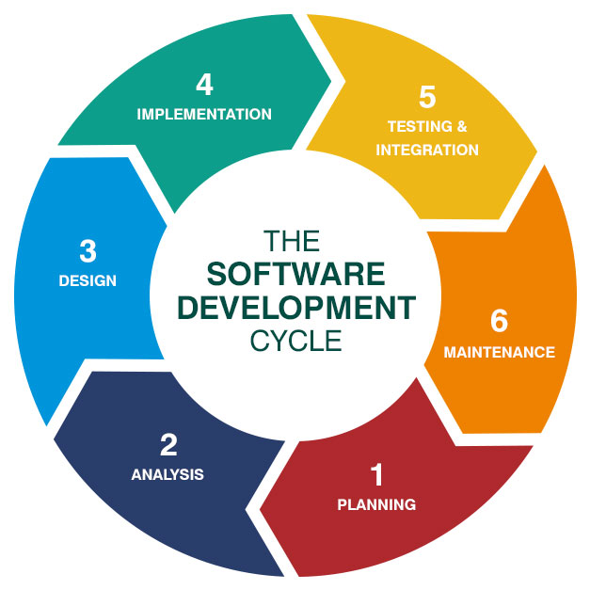

* 1. **Process Description**

Gantt charts mainly used to allocate resources to activities. The resources allocated to activities include staff, hardware, and software. Gantt charts (named after its developer Henry Gantt) are useful for resource planning. A Gantt chart is special type of bar chart where each bar represents an activity. The bars are drawn along a timeline. The length of each bar is proportional to the duration of the time planned for the corresponding activity.

Gantt chart is a project scheduling technique. Progress can be represented easily in a Gantt chart, by coloring each milestone when completed. The project will start in the month of January and end after 4 months at the beginning of April.

* 1. **PROJECT MODEL USED**

**Iterative Enhancement Model**

* This model has the same phases as the waterfall model, but with fewer restrictions. Generally, the phases occur in the same order as in the waterfall model, but they may be conducted in several cycles.
* Useable product is released at the end of the each cycle, with each release providing additional functionality. Customers and developers specify as many requirements as possible and prepare a SRS document. Developers and customers then prioritize these requirements. Developers implement the specified requirements in one or more cycles of design, implementation and test based on the defined priorities.

The procedure itself consists of the initialization step, the iteration step, and the Project Control List. The initialization step creates a base version of the system. The goal for this initial implementation is to create a product to which the user can react. It should offer a sampling of the key aspects of the problem and provide a solution that is simple enough to understand and implement easily. To guide the iteration process, a project control list is created that contains a record of all tasks that need to be performed. It includes such items as new features to be implemented and areas of redesign of the existing solution. The control list is constantly being revised as a result of the analysis phase.

The iteration involves the redesign and implementation of iteration is to be simple, straightforward, and modular, supporting redesign at that stage or as a task added to the project control list. The level of design detail is not dictated by the iterative approach. In a light-weight iterative project the code may represent the major source of [documentation](http://en.wikipedia.org/wiki/Software_documentation) of the system; however, in a critical iterative project a formal [Software Design Document](http://en.wikipedia.org/wiki/Software_Design_Document) may be used. The analysis of an iteration is based upon user feedback, and the program analysis facilities available. It involves analysis of the structure, modularity, [usability](http://en.wikipedia.org/wiki/Usability), reliability, efficiency, & achievement of goals. The project control list is modified in light of the analysis results.

**PHASES:**

Incremental development slices the system functionality into increments (portions). In each increment, a slice of functionality is delivered through cross- discipline work, from the requirements to the deployment. The unified process groups increments/iterations into phases: inception, elaboration, construction, and transition.

* Inception identifies project scope, requirements (functional and non-functional) and risks at a high level but in enough detail that work can be estimated.
* Elaboration delivers a working architecture that mitigates the top risks and fulfills the non-functional requirements.
* Construction incrementally fills-in the architecture with production-ready code produced from analysis, design, implementation, and testing of the functional requirements.
* Transition delivers the system into the production operating environment.

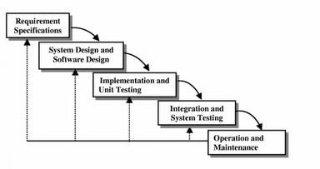

* 1. **ER-Diagram**

**Introduction: -**

I[n software engineering, an](http://en.wikipedia.org/wiki/Software_engineering) entity-relationship model (ERM) is an abstract and conceptual representation of [data.](http://en.wikipedia.org/wiki/Data) Entity-relationship modeling is a [database modeling](http://en.wikipedia.org/wiki/Database_model) [method,](http://en.wikipedia.org/wiki/Database_model) used to produce a type [of conceptual schema](http://en.wikipedia.org/wiki/Conceptual_schema) o[r semantic data model of](http://en.wikipedia.org/wiki/Semantic_data_model) a system, often [a relational database, a](http://en.wikipedia.org/wiki/Relational_database)nd its require[ments in a top-down](http://en.wikipedia.org/wiki/Top-down) fashion. Diagrams created by this process are called entity-relationship diagrams, ER diagrams, or ERDs. ER Diagrams depicts relationship between data objects. The attribute of each data objects noted in the entity-relationship diagram can be described using a data object description. Entity relationship diagram is very basic, conceptual model of data and it is fundamental to the physical database design. This analysis is then used to organize data as relations, normalizing relations, and obtaining a Relational database.

The entity-relationship model for data uses three features to describe data. These are:

1. Entities which specify distinct real-world items in an application.
2. Relationship, which connect entities and represent meaningful dependencies between them.
3. Attributes which specify properties of entities &relationships.

**E-R Diagram**

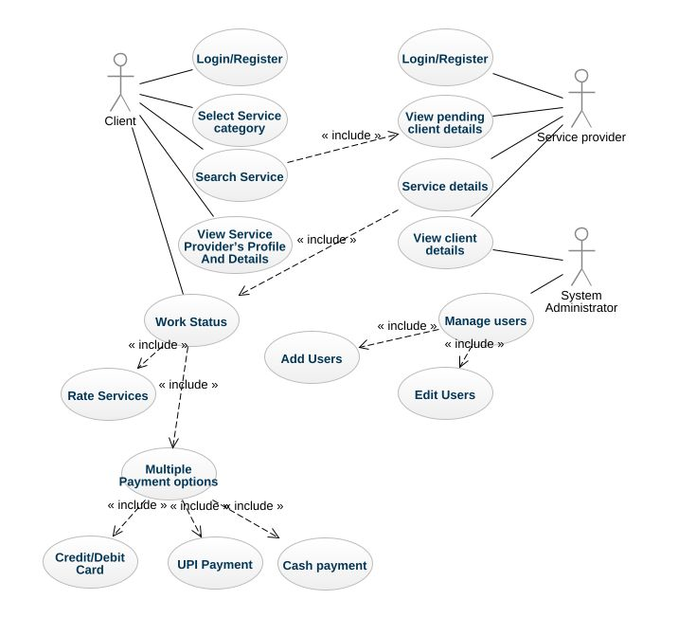

* 1. **Data Flow Diagram**

**Introduction:**

DFD is an acronym for the word Data Flow Diagram. DFD is ppictorial representation of the system. DFD is a graphical representation of the flow of data through the information system. DFD are also used for the visualization of data processing (structured design). ADFD provides no information about the timings of the process, or about whether process will operate in parallel or sequence. DFD is an important technique for modeling system’s high-level detail by showing how input data is transformed to output results through a sequence of functional transformations. DFD reveal relationships among between the various components in a program or system. The strength of DFD lies in the fact that using few symbols we are able to express program design in an easier manner. ADFD can be used to represent the following:

* External Entity sending and receiving data. Process that change the data.
* Flow of data within the system. Data Storage locations.

**Uses of DFD:**

The main uses of data flow diagrams are as follows: -

DFD is a method of choice for representation of showing of information through a system because of the following reasons:

* + - DFDs are easier to understand by technical and non-technical audiences.
    - DFDs can provide a high-level system overview, complete with boundaries and connections to other system
    - DFDs can provide a detailed representation of system components.

1. **Level DFD**

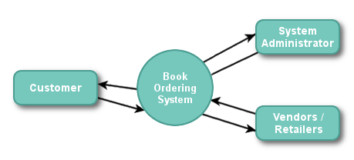

1. **Level DFD**

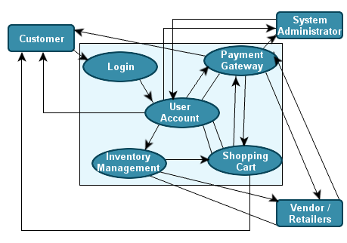

1. **SOFTWARE HARDWARE REQUIREMENT SPECIFICATION**

A requirements specification for a software system is a complete description of the behavior of a system to be developed and it includes a set of use cases that describe all the interactions the users will have with the software. In addition to use cases, the SRS also contains non-functional requirements.

Non-functional requirements are requirements which impose constraints on the design or implementation (such as performance engineering requirements, quality standards, or design constraints) Requirements are a sub-field of software engineering that deals with the elicitation, analysis, specification, and validation of requirements for software.

The software requirement specification document enlists all necessary requirements for project development. To derive the requirements we need to have clear and thorough understanding of the products to be developed. This is prepared after detailed communications with project team and the customer.

* 1. **SERVER SIDE HARDWARE REQUIREMENT:**
* AMD Athlon 64 with processor speed 2.8 or more
* 256 DDR Ram
* 40 GB Hard disk
* Network Interface card
* IIS
* CD-Drive

* 1. **SERVER SIDE SOFTWARE REQUIREMENT:**
* Windows
* Python 3.7 and PyCharm IDE 2021.3
* SQLite

**CLIENT SIDE HARDWARE REQUIREMENT:**

* Processor Dual core-based computer
* 2 GB Minimum RAM
* 20 GB HDD
* 100 Mbps LAN
* Web Browser

**TO DEVELOP THIS PROJECT THE VARIOUS SOFTWARE RESOURCES ARE USED.**

* Front End                - HTML-CSS &Bootstrap
* Back End                 - SQLite
* Web Server             - Apache Server
* Technology               - Python technology
* Code-Behind Language   - Python
* IDE                                 - PyCharm
  1. **SUPPORT AND MAINTENANCE:**

One-year free support for rectifying system bugs including front end and beck end will be provided. During warranty period Software Engineers will be responsible for removing bugs and improving it. After one year support can be extended @ 20% of the total product deployment cost.

1. **SYSTEM DESIGN APPROACH**

* 1. **Top – Down designing:**

The top - down designing approach started with major components of the system. It is a stepwise refinement which starts from an abstract design, in each steps the design is refined two or more concrete levels until we reach a level where no – more refinement is possible or not needed.

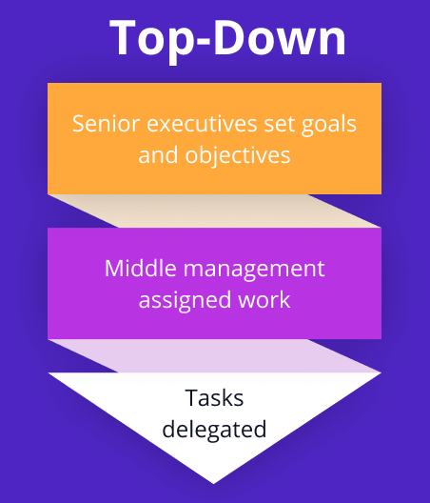

* 1. **Bottom – Up designing:**

In bottom – up designing the most basic and primitive components are designed first, and we proceed to higher level components. We work with layers of abstractions and abstraction are implemented until the stage is reached where the operations supported by the layer is complete.

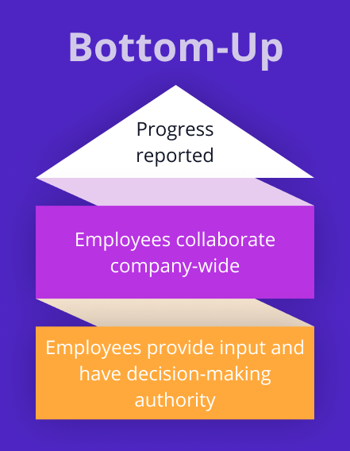

* 1. **Following Approach:**

In this project we are following **Mixed Approach** i.e. A combination of top – down and bottom – up. We are developing some of the components using top – down designing approach (e.g. the WebPages) and the some components in bottom – up designing approach (e.g. the middle tier classes).

1. **BACKEND DESIGN**
   1. **Description of Classes and Methods (model.py)**

from django.db import models  
from tinymce.models import HTMLField  
  
# Create your models here.  
class contactus(models.Model):  
 Name=models.CharField(max_length=50,null=True)  
 Email=models.EmailField(max_length=50,null=True)  
 Mobile=models.CharField(max_length=50,null=True)  
 Message=models.TextField(null=True)  
class category(models.Model):  
 category_name=models.CharField(max_length=100,null=True)  
 category_picture=models.ImageField(upload_to='static/category/',null=True)  
 def __str__(self):  
 return self.category_name  
class tbl_register(models.Model):  
 name=models.CharField(max_length=50,null=True)  
 email=models.EmailField(max_length=100,primary_key=True)  
 mobile=models.CharField(max_length=22,null=True)  
 pincode=models.IntegerField(null=True)  
 city=models.CharField(max_length=40,null=True)  
 address=models.TextField(null=True)  
 password=models.CharField(max_length=25,null=True)  
 picture=models.ImageField(upload_to='static/profilepicture/',null=True)  
class tbl_slider(models.Model):  
 picture=models.ImageField(upload_to='static/slider/',null=True)  
 title=models.CharField(max_length=40,null=True)  
 description=models.TextField(null=True)  
class service_provider(models.Model):  
 provider_name=models.CharField(max_length=50,null=True)  
 provider_picture=models.ImageField(upload_to='static/provider/',null=True)  
 avg_price=models.FloatField()  
 discount_price=models.FloatField()  
 service_name=models.CharField(max_length=200,null=True)  
 details=models.TextField(null=True)  
 availability=HTMLField(null=True)  
 provider_mobile=models.CharField(max_length=50,null=True)  
 city=models.CharField(max_length=100,null=True)  
 address=models.TextField(null=True)  
 service_picture=models.ImageField(upload_to='static/service/',null=True)  
 service_category=models.ForeignKey(category,on_delete=models.CASCADE)  
 pincode=models.IntegerField()  
 added_date=models.DateField(null=True)  
 def __str__(self):  
 return self.provider_name  
class tbl_service(models.Model):  
 service_title=models.CharField(max_length=50,null=True)  
 provider_name = models.ForeignKey(service_provider, on_delete=models.CASCADE)  
 description=models.TextField(null=True)  
 cost=models.IntegerField()  
 avg_time=models.CharField(max_length=50,null=True)  
 service_pic=models.ImageField(upload_to='static/servicepic/',null=True)  
class tbl_booking(models.Model):  
 providerid =models.ForeignKey(service_provider,on_delete=models.CASCADE)  
 email= models.ForeignKey(tbl_register,on_delete=models.CASCADE)  
 date = models.DateField(null=True)  
 time = models.TimeField(null=True)  
 detail = models.TextField(null=True)  
 address = models.TextField(null=True)  
 city = models.CharField(max_length=50,null=True)  
 pincode = models.IntegerField(null=True)  
 payment = models.IntegerField(null=True)  
 reqdate = models.DateField(null=True)  
 status = models.CharField(max_length=50,null=True)

* 1. **Defined urls (urls.py)**

**Project Level – URL.PY**

* **Urls.py**

from django.contrib import admin  
from django.urls import path,include  
  
urlpatterns = [  
 path('admin/', admin.site.urls),  
 path('',include('user.urls')),  
]

* **Settings.py**

from pathlib import Path  
  
# Build paths inside the project like this: BASE_DIR / 'subdir'.  
BASE_DIR = Path(__file__).resolve().parent.parent  
TEMPLATE_DIR=BASE_DIR/'templates'  
  
# Quick-start development settings - unsuitable for production  
# See https://docs.djangoproject.com/en/5.1/howto/deployment/checklist/  
  
# SECURITY WARNING: keep the secret key used in production secret!  
SECRET_KEY = 'django-insecure-v6h$k77uu^697btv+(%#@h%y2gul#=(g1z_)%_*=vba_khs2_7'  
  
# SECURITY WARNING: don't run with debug turned on in production!  
DEBUG = True  
  
ALLOWED_HOSTS = []  
  
  
# Application definition  
  
INSTALLED_APPS = [  
 'django.contrib.admin',  
 'django.contrib.auth',  
 'django.contrib.contenttypes',  
 'django.contrib.sessions',  
 'django.contrib.messages',  
 'django.contrib.staticfiles',  
 'user',  
 'tinymce',  
]  
  
MIDDLEWARE = [  
 'django.middleware.security.SecurityMiddleware',  
 'django.contrib.sessions.middleware.SessionMiddleware',  
 'django.middleware.common.CommonMiddleware',  
 'django.middleware.csrf.CsrfViewMiddleware',  
 'django.contrib.auth.middleware.AuthenticationMiddleware',  
 'django.contrib.messages.middleware.MessageMiddleware',  
 'django.middleware.clickjacking.XFrameOptionsMiddleware',  
]  
  
ROOT_URLCONF = 'MyProject.urls'  
  
TEMPLATES = [  
 {  
 'BACKEND': 'django.template.backends.django.DjangoTemplates',  
 'DIRS': [TEMPLATE_DIR],  
 'APP_DIRS': True,  
 'OPTIONS': {  
 'context_processors': [  
 'django.template.context_processors.debug',  
 'django.template.context_processors.request',  
 'django.contrib.auth.context_processors.auth',  
 'django.contrib.messages.context_processors.messages',  
 ],  
 },  
 },  
]  
  
WSGI_APPLICATION = 'MyProject.wsgi.application'  
  
  
# Database  
# https://docs.djangoproject.com/en/5.1/ref/settings/#databases  
  
DATABASES = {  
 'default': {  
 'ENGINE': 'django.db.backends.sqlite3',  
 'NAME': BASE_DIR / 'db.sqlite3',  
 }  
}  
  
  
# Password validation  
# https://docs.djangoproject.com/en/5.1/ref/settings/#auth-password-validators  
  
AUTH_PASSWORD_VALIDATORS = [  
 {  
 'NAME': 'django.contrib.auth.password_validation.UserAttributeSimilarityValidator',  
 },  
 {  
 'NAME': 'django.contrib.auth.password_validation.MinimumLengthValidator',  
 },  
 {  
 'NAME': 'django.contrib.auth.password_validation.CommonPasswordValidator',  
 },  
 {  
 'NAME': 'django.contrib.auth.password_validation.NumericPasswordValidator',  
 },  
]  
  
  
# Internationalization  
# https://docs.djangoproject.com/en/5.1/topics/i18n/  
  
LANGUAGE_CODE = 'en-us'  
  
TIME_ZONE = 'UTC'  
  
USE_I18N = True  
  
USE_TZ = True  
  
  
# Static files (CSS, JavaScript, Images)  
# https://docs.djangoproject.com/en/5.1/howto/static-files/  
  
STATIC_DIR=BASE_DIR/'static'  
STATIC_URL = 'static/'  
STATICFILES_DIRS=[STATIC_DIR]  
  
# Default primary key field type  
# https://docs.djangoproject.com/en/5.1/ref/settings/#default-auto-field  
  
DEFAULT_AUTO_FIELD = 'django.db.models.BigAutoField'

**APP LEVEL- URLS.PY**

* **Views.py**

from django.db.models import Q  
from django.db import connection  
from django.shortcuts import render  
from . models import *  
from django.http import HttpResponse  
from django.shortcuts import get_object_or_404  
from datetime import datetime  
from django.utils import timezone  
  
# Create your views here.  
def index(request):  
 data=category.objects.all().order_by('-id')[0:12]  
 sdata=service_provider.objects.all().order_by('-discount_price')[0:12]  
 md={'cdata':data,'servicedata':sdata}  
 return render(request,'index.html',md)  
def about(request):  
 return render(request,'about.html')  
def contact(request):  
 md={}  
 if request.method=="POST":  
 a=request.POST.get('name')  
 b=request.POST.get('email')  
 c=request.POST.get('mobile')  
 d=request.POST.get('msg')  
 contactus(Name=a,Email=b,Mobile=c,Message=d).save()  
 return HttpResponse("<script>alert('Thanks for contacting with us...');location.href='/contact/';</script>")  
 #md={"name":a,"email":b,"mobile":c,"message":d}  
 return render(request,'contact.html')  
def faqs(request):  
 return render(request,'faqs.html')  
def register(request):  
 if request.method=="POST":  
 name=request.POST.get('name')  
 email=request.POST.get('email')  
 mobile=request.POST.get('mobile')  
 password=request.POST.get('password')  
 address=request.POST.get('address')  
 pincode=request.POST.get('pincode')  
 city=request.POST.get('city')  
 picture=request.FILES['fu']  
 x=tbl_register.objects.all().filter(email=email).count()  
 if x==1:  
 return HttpResponse("<script>alert('You Are Already Registered');location.href='/register/';</script>")  
 else:  
 tbl_register(name=name, email=email,mobile=mobile, password=password,address=address, pincode=pincode, city=city, picture=picture).save()  
 return HttpResponse("<script>alert('Thanks for registering...');location.href='/register/';</script>")  
 return render(request,'register.html')  
  
def service(request):  
 sid=request.GET.get('msg')  
 sdata=service_provider.objects.all().filter(id=sid)  
 services =tbl_service.objects.all().filter(provider_name=sid)  
 md={"sdata":sdata}  
 return render(request,'service.html',md)  
def login(request):  
 if request.method=="POST":  
 email=request.POST.get('email')  
 password=request.POST.get('password')  
 x=tbl_register.objects.filter(email=email, password=password)  
 if x.count()==1 :  
 request.session['name']=str(x[0].name)  
 request.session['picture']=str(x[0].picture)  
 request.session['email']=str(x[0].email)  
 return HttpResponse("<script>alert('You are Welcome...');location.href='/home/';</script>")  
 else :  
 return HttpResponse("<script>alert('Invalid Credentials');location.href='/home/';</script>")  
 return render(request,'login.html')  
def logout(request):  
 if request.session.get('email'):  
 del request.session['email']  
 return HttpResponse("<script>alert('You are Logged Out');location.href='/login/';</script>")  
 return render(request,'login.html')  
def allservices(request):  
 cid=request.GET.get('cid')  
 searchdata=request.GET.get('search')  
 cdata=category.objects.all().order_by('-id')  
 data=""  
 if cid is not None:  
 data=service_provider.objects.all().filter(service_category=cid)  
 elif searchdata is not None:  
 data=service_provider.objects.all().filter(Q(service_name__icontains=searchdata) | Q(address__icontains=searchdata) | Q(city__icontains=searchdata) | Q(availability__icontains=searchdata) | Q(service_category__category_name__icontains=searchdata))  
 else:  
 data=service_provider.objects.all().order_by('-id')  
 md={"cdata":cdata,"servicedata":data}  
 return render(request,'allservices.html',md)  
def profile(request):  
 if request.method=="POST":  
 name=request.POST.get('name')  
 email=request.POST.get('email')  
 mobile=request.POST.get('mobile')  
 password=request.POST.get('password')  
 address=request.POST.get('address')  
 pincode=request.POST.get('pincode')  
 city=request.POST.get('city')  
 picture=request.FILES['fu']  
 tbl_register(name=name, email=email,mobile=mobile, password=password,address=address, pincode=pincode, city=city, picture=picture).save()  
 return HttpResponse("<script>location.href='/profile/';</script>")  
 user=request.session.get('email')  
 data=tbl_register.objects.all().filter(email=user)  
 md={"userinfo":data}  
 return render(request,'profile.html',md)  
def bookinghistory(request):  
 cursor = connection.cursor()  
 email=request.session.get('email')  
 # cursor.execute("select * from user_tbl_booking left join user_service_provider on user_tbl_booking.providerid=user_service_provider.id where user_tbl_booking.email='"+email+"' order by user_tbl_booking.id desc")  
 # rows=cursor.fetchall()  
 rows = tbl_booking.objects.all().order_by('reqdate')  
 md={"data":rows}  
 return render(request,'bookinghistory.html',md)  
def booking(request):  
 email = request.session.get('email')  
 email = get_object_or_404(tbl_register,email=email)  
 #print(email)  
 if email is not None:  
 if request.method=="POST":  
 date= request.POST.get('date')  
 time = request.POST.get('time')  
 detail= request.POST.get('detail')  
 address= request.POST.get('address')  
 pincode = request.POST.get('pin')  
 city= request.POST.get('city')  
 payment= request.POST.get('payment')  
 now= datetime.today()  
 provider_id =request.POST.get('number')  
 provider_id = get_object_or_404(service_provider,id= provider_id)  
 tbl_booking(providerid=provider_id,email=email,date=now,time=time,detail=detail,address=address,pincode=pincode,payment=payment,city=city,reqdate=date,status="booked").save()  
 return HttpResponse("<script>alert('service booked successfully');location.href='/bookinghistory/';</script>")  
 else:  
 return HttpResponse("<script>alert('you are not login');window.location.href='/login/'</script>")  
 return render(request, 'booking.html')

* **Urls.py**

from django.urls import path  
from . import views  
urlpatterns=[  
 path('',views.index),  
 path('home/',views.index),  
 path('about/',views.about),  
 path('contact/',views.contact),  
 path('faqs/',views.faqs),  
 path('register/',views.register),  
 path('service/',views.service),  
 path('login/',views.login),  
 path('logout/',views.logout),  
 path('allservices/',views.allservices),  
 path('profile/',views.profile),  
 path('booking/',views.booking),  
 path('bookinghistory/', views.bookinghistory),  
]

* **Models.py**

from django.db import models  
from tinymce.models import HTMLField  
  
# Create your models here.  
class contactus(models.Model):  
 Name=models.CharField(max_length=50,null=True)  
 Email=models.EmailField(max_length=50,null=True)  
 Mobile=models.CharField(max_length=50,null=True)  
 Message=models.TextField(null=True)  
class category(models.Model):  
 category_name=models.CharField(max_length=100,null=True)  
 category_picture=models.ImageField(upload_to='static/category/',null=True)  
 def __str__(self):  
 return self.category_name  
class tbl_register(models.Model):  
 name=models.CharField(max_length=50,null=True)  
 email=models.EmailField(max_length=100,primary_key=True)  
 mobile=models.CharField(max_length=22,null=True)  
 pincode=models.IntegerField(null=True)  
 city=models.CharField(max_length=40,null=True)  
 address=models.TextField(null=True)  
 password=models.CharField(max_length=25,null=True)  
 picture=models.ImageField(upload_to='static/profilepicture/',null=True)  
class tbl_slider(models.Model):  
 picture=models.ImageField(upload_to='static/slider/',null=True)  
 title=models.CharField(max_length=40,null=True)  
 description=models.TextField(null=True)  
class service_provider(models.Model):  
 provider_name=models.CharField(max_length=50,null=True)  
 provider_picture=models.ImageField(upload_to='static/provider/',null=True)  
 avg_price=models.FloatField()  
 discount_price=models.FloatField()  
 service_name=models.CharField(max_length=200,null=True)  
 details=models.TextField(null=True)  
 availability=HTMLField(null=True)  
 provider_mobile=models.CharField(max_length=50,null=True)  
 city=models.CharField(max_length=100,null=True)  
 address=models.TextField(null=True)  
 service_picture=models.ImageField(upload_to='static/service/',null=True)  
 service_category=models.ForeignKey(category,on_delete=models.CASCADE)  
 pincode=models.IntegerField()  
 added_date=models.DateField(null=True)  
 def __str__(self):  
 return self.provider_name  
class tbl_service(models.Model):  
 service_title=models.CharField(max_length=50,null=True)  
 provider_name = models.ForeignKey(service_provider, on_delete=models.CASCADE)  
 description=models.TextField(null=True)  
 cost=models.IntegerField()  
 avg_time=models.CharField(max_length=50,null=True)  
 service_pic=models.ImageField(upload_to='static/servicepic/',null=True)  
class tbl_booking(models.Model):  
 providerid =models.ForeignKey(service_provider,on_delete=models.CASCADE)  
 email= models.ForeignKey(tbl_register,on_delete=models.CASCADE)  
 date = models.DateField(null=True)  
 time = models.TimeField(null=True)  
 detail = models.TextField(null=True)  
 address = models.TextField(null=True)  
 city = models.CharField(max_length=50,null=True)  
 pincode = models.IntegerField(null=True)  
 payment = models.IntegerField(null=True)  
 reqdate = models.DateField(null=True)  
 status = models.CharField(max_length=50,null=True)

* **Admin.py**

from django.contrib import admin  
from . models import *  
# Register your models here.  
  
class contactusAdmin(admin.ModelAdmin):  
 list_display = ('id','Name','Email','Mobile','Message')  
admin.site.register(contactus,contactusAdmin)  
  
class categoryAdmin(admin.ModelAdmin):  
 list_display = ('id','category_name','category_picture')  
admin.site.register(category, categoryAdmin)  
  
class tbl_registerAdmin(admin.ModelAdmin):  
 list_display = ('name','email','mobile','pincode','city','address','password','picture')  
admin.site.register(tbl_register, tbl_registerAdmin)  
  
class service_providerAdmin(admin.ModelAdmin):  
 list_display = ('id','provider_name','provider_picture','avg_price','discount_price','service_name','details','availability','provider_mobile','city','address','service_picture','service_category','pincode','added_date')  
admin.site.register(service_provider, service_providerAdmin)  
  
class tbl_serviceAdmin(admin.ModelAdmin):  
 list_display = ('id','service_title','provider_name','description','cost','avg_time','service_pic')  
admin.site.register(tbl_service, tbl_serviceAdmin)  
  
class tbl_bookingAdmin(admin.ModelAdmin):  
 list_display = ('providerid','email','date','time','detail','address','city','pincode','payment','reqdate','status')  
admin.site.register(tbl_booking,tbl_bookingAdmin)

1. **DATA MODELING**
   1. **LIST OF TABLES:**
      1. **Category Table**

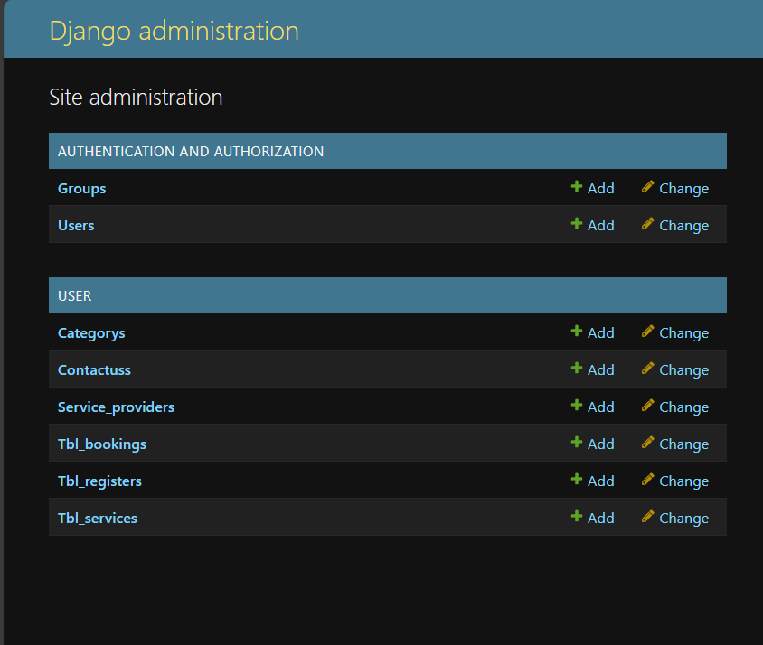

* + 1. **STRUCTURE OF TABLES:**
    2. C**ategory Table**
* **Categorys**

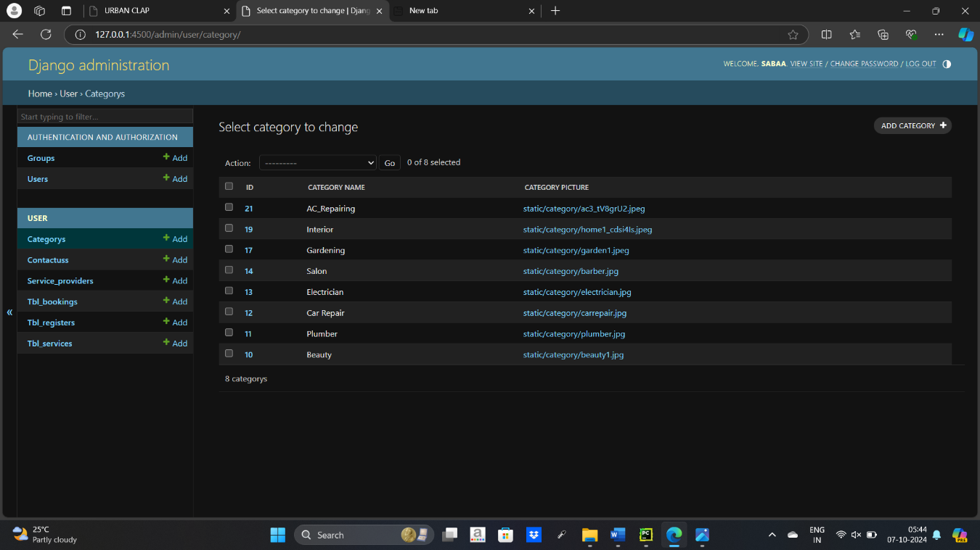

* **Contactuss**

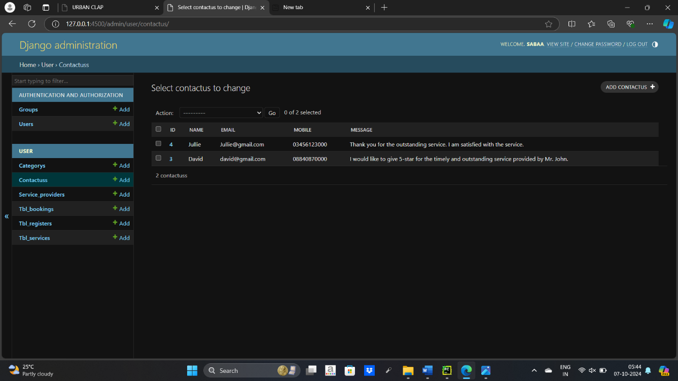

* **Service_providers**

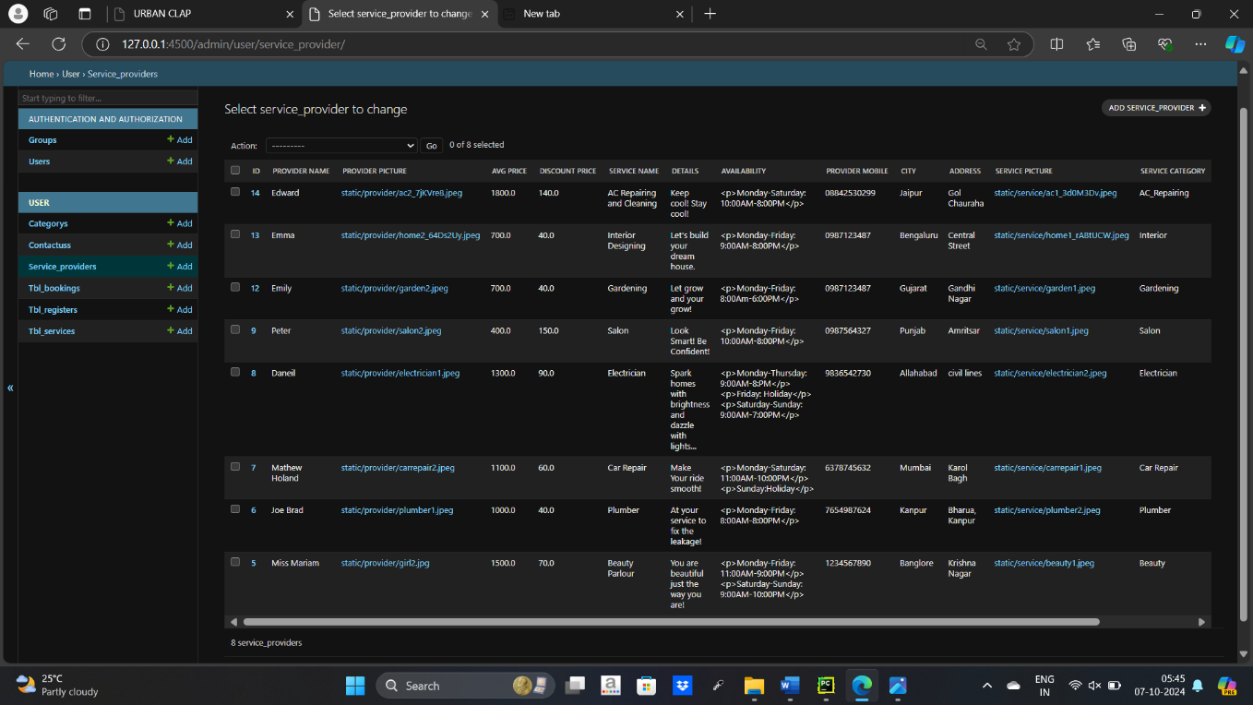

* **Tbl_bookings**

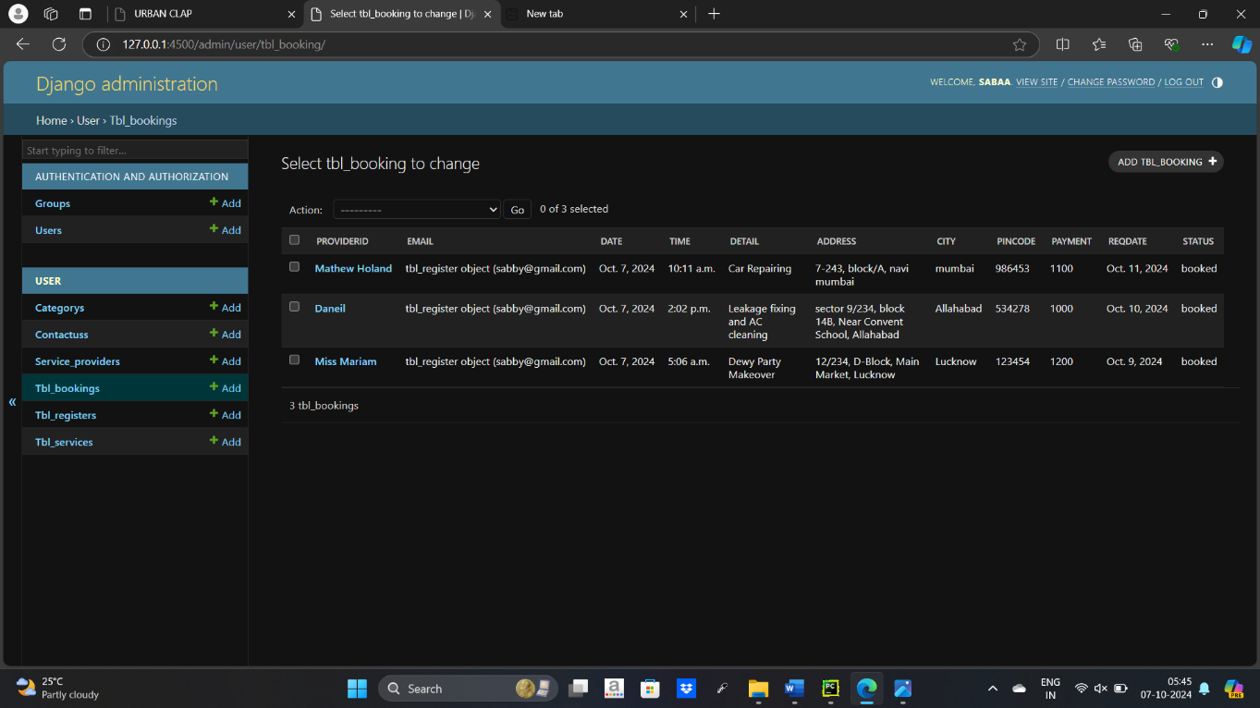

* **Tbl_registers**

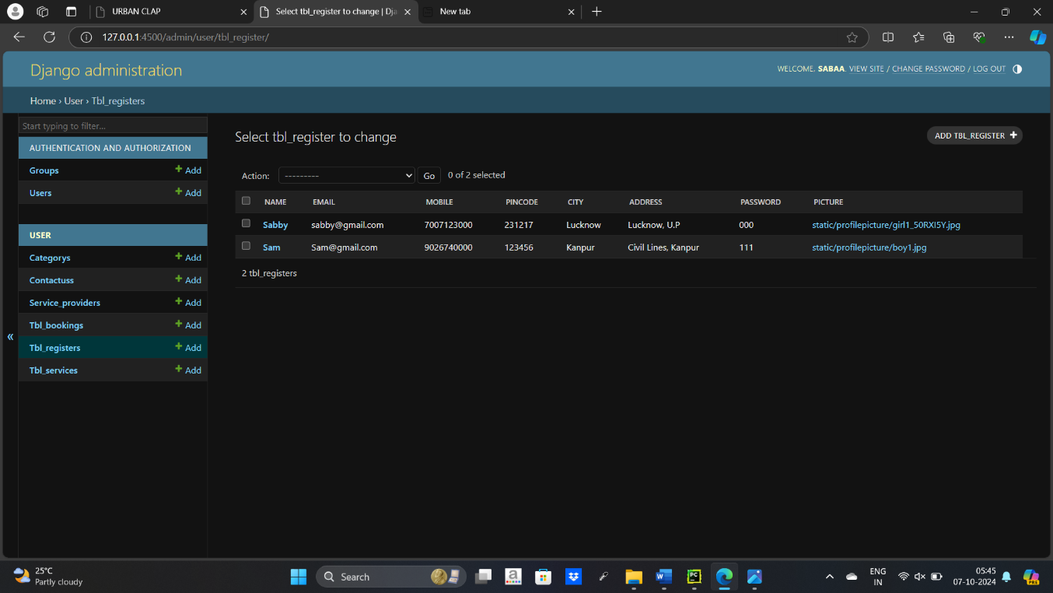

* **Tbl_services**

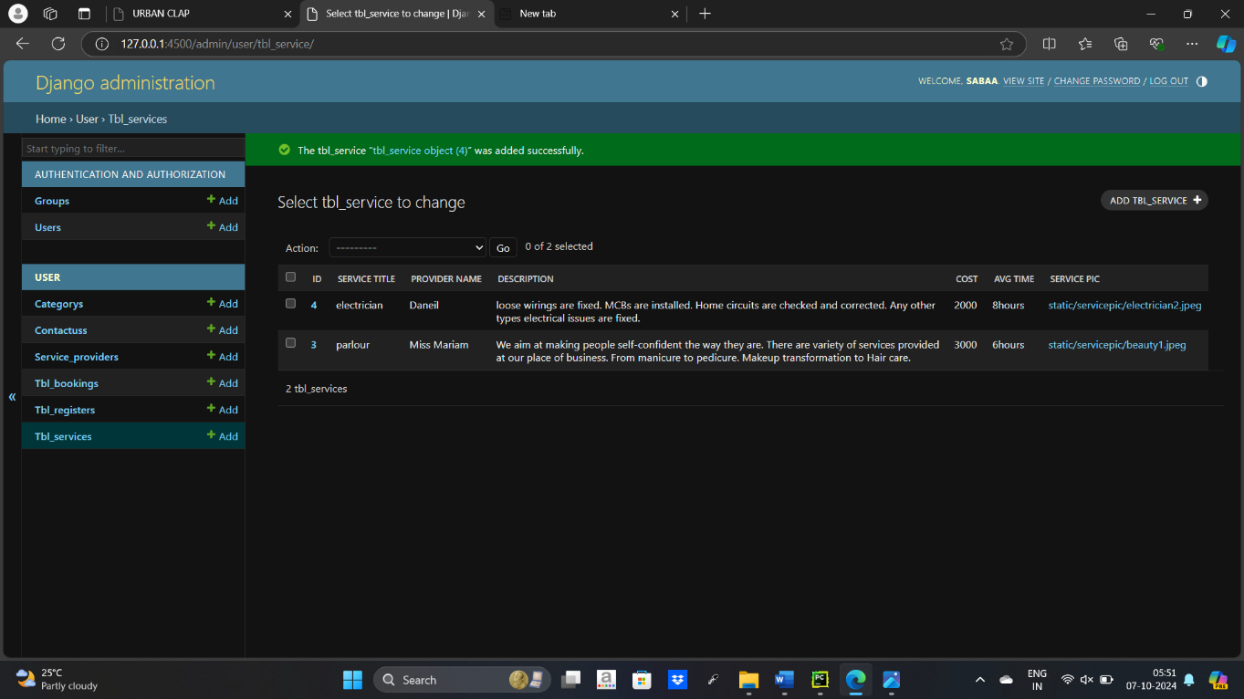

1. **TESTING**

Testing is the integral part of any System Development Life Cycle insufficient and interested application tends to crash and result in loss of economic and manpower investment besides user’s dissatisfaction and downfall of reputation.

“Software Testing can be looked upon as one among much process, an organization performs, and that provides the last opportunity to correct any flaws in the developed system. Software Testing includes selecting test data that have more probability of giving errors.” The first step in System testing is to develop the plan that all aspect of system Complements, Correctness, Reliability and Maintainability.

Software is to be tested for the best quality assurance, an assurance that system meets the specification and requirement for its intended use and performance.

System Testing is the most useful practical process of executing the program with the implicit intention of finding errors that makes the program fail.

**Types of Testing:**

**Black Box (Functional) Testing:**

Testing against specification of system or component. Study it by examining its inputs and related outputs. Key is to devise inputs that have a higher likelihood of causing outputs that reveal the presence of defects. Use experience and knowledge of domain to identify such test cases. Failing this a systematic approach may be necessary. Equivalence partitioning is where the input to a program falls into a number of classes,

e.g. positive numbers vs. negative numbers. Programs normally behave the same way for each member of a class. Partitions exist for both input and output. Partitions may be discrete or overlap. Invalid data (i.e. outside the normal partitions) is one or more partitions that should be tested.

Internal System design is not considered in this type of testing. Tests are based on requirements and functionality.

This type of test case design method focuses on the functional requirements of the software, ignoring the control structure of the program. Black box testing attempts to find errors in the following categories:

* + Incorrect or missing functions.
  + Interface errors.
  + Errors in data structures or external database access.
  + Performance errors.
  + Initialization and termination errors.

**White Box (Structural) Testing:**

Testing based on knowledge of structure of component (e.g., by looking at source code). Advantage is that structure of code can be used to find out how many test case need to be performed. Knowledge of the algorithm (examination of the code) can be used to identify the equivalence partitions. Path testing is where the tester aims to exercise every independent execution path through the component. All conditional statements tested for both true and false cases. If a unit has n control statements, there program units than large ones. Flow graphs are a pictorial representation of the paths of control through a program (ignoring assignments, procedure calls and I/O statements).

Use flow graph to design test cases that execute each path. Static tools may be used to make this easier in programs that have a complex branching structure. Tools support. Dynamic program analyzers instrument a program with additional code. Typically, this will count how many times each statement is executed. At end print out report showing which statements have and have not been executed. Problems with flow graph derived testing:

* Data complexity could not take into account.
* We cannot test all paths in combination.
* In really only possible at unit and module testing stages because beyond that complexity is too high.

This testing is based on knowledge of the internal logic of an application’s code. Also known as a Glass Box Testing Internal software and code working should be known for this type of testing. Tests are based on coverage of code statements, branches, paths, conditions.

**Unit Testing:**

Unit testing concentrates on each unit of the software as implemented in the code. This is done to check syntax and logical errors in programs. At this stage, the test focuses on each module individually, assuring that it functions properly as a unit. In our case, we used extensive white-box testing at the unit testing stage.

A developer and his team typically do the unit testing do the unit testing is done in parallel with coding; it includes testing each function and procedure.

**Incremental Integration Testing:**

Bottom-up approach for testing i.e. continuous testing of an application as new functionality is added; Application functionality and modules should be independent enough to test separately done by programmers or by testers.

**Integration Testing:**

Testing of integration modules to verify combined functionality after integration .Modules are

typically code modules, individual applications, client and server and distributed systems.

**Functional Testing:**

This type of testing ignores the internal parts and focus on the output is as per requirement or not. Black box type testing geared to functionality requirements of an application.

**System Testing:**

Entire system is tested as per the requirements. Black box type test that is based on overall requirement specifications covers all combined parts of a system.

**End-to-End Testing:**

Similar to system testing involves testing of a complete application environment in a situation that mimics real-world use, such as interacting with a database using network communications, or interacting with hardware, applications, or system if appropriate.

**Regression Testing:**

Testing the application as a whole for the modification in any module or functionality. Difficult to cover all the system in regression testing so typically automation tools are used for these testing types.

**Acceptance Testing:**

Normally this type of testing is done to verify if system meets the customer specified requirements. User or customers do this testing to determine whether to accept application.

**Performance Testing:**

Term often used interchangeably with “stress” and “load” testing, To check whether system meets performance requirements, Used different performance and load tools to do this.

**Alpha Testing:**

In house virtual user environment can be created for this type of testing. Testing is done at the end of development still minor design changes may be made as a result of such testing.

**Beta Testing:**

Testing typically done by end-users or others. This is final testing before releasing application for commercial purpose.

1. **Input-output Forms(SCREENSHOTS AND CODING)**
   1. **HOME.PY** 
      1. **SCREENSHOTS**

* Base/index

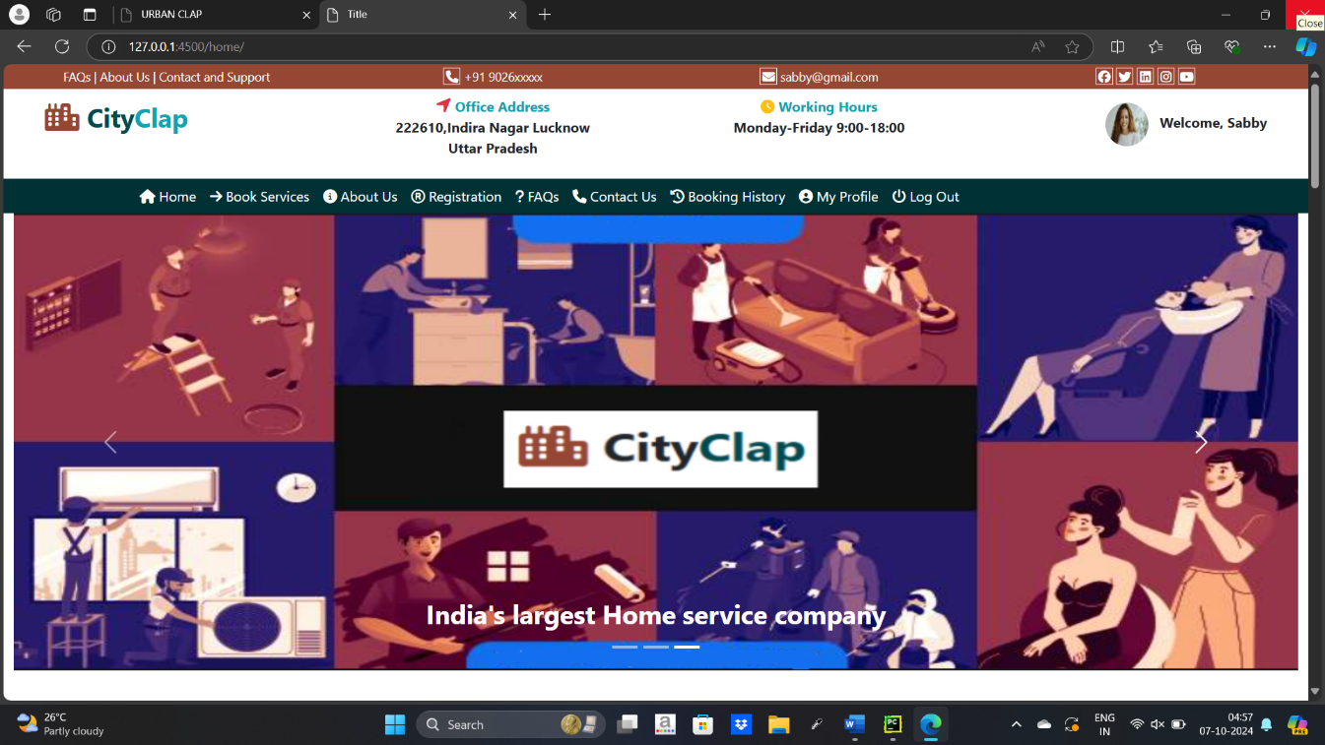

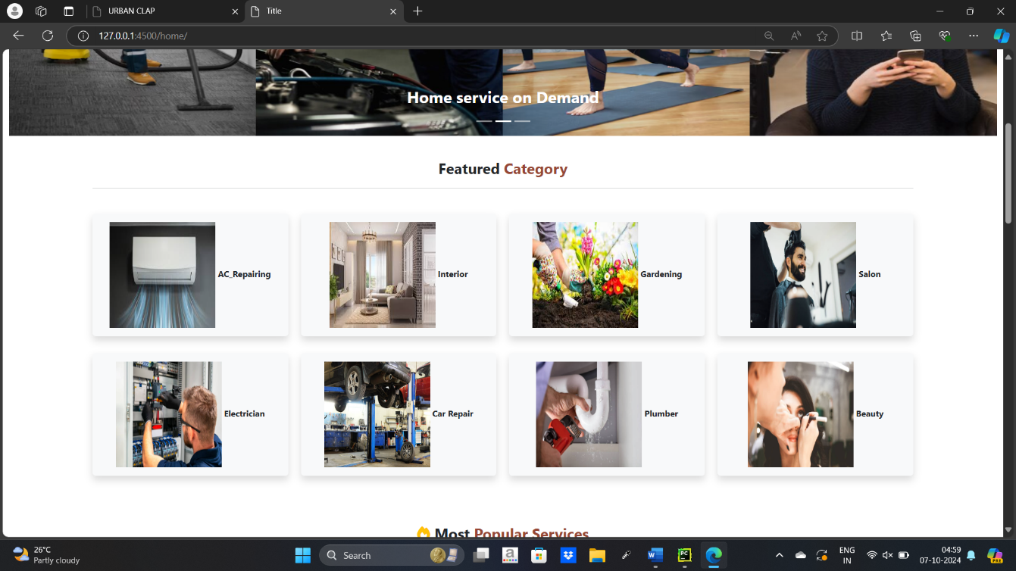 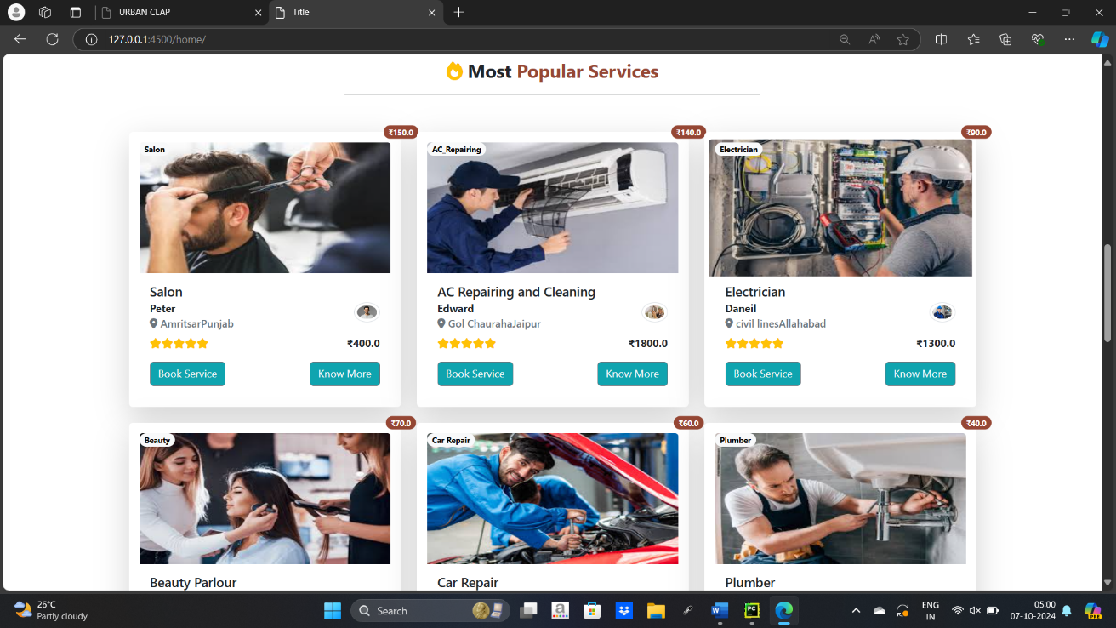

* Footer

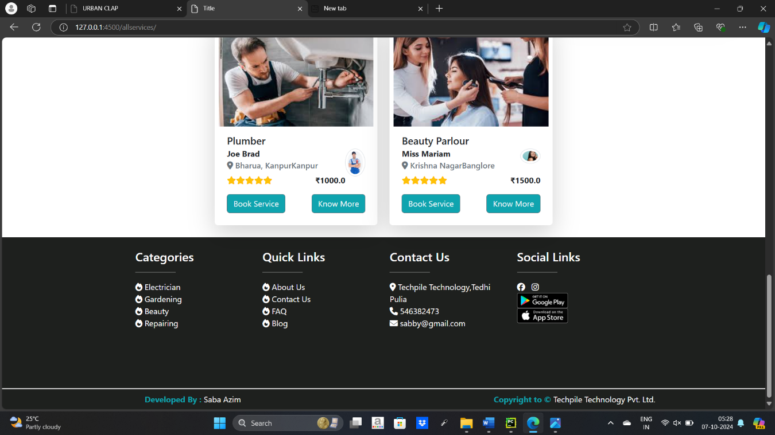

* Allservices

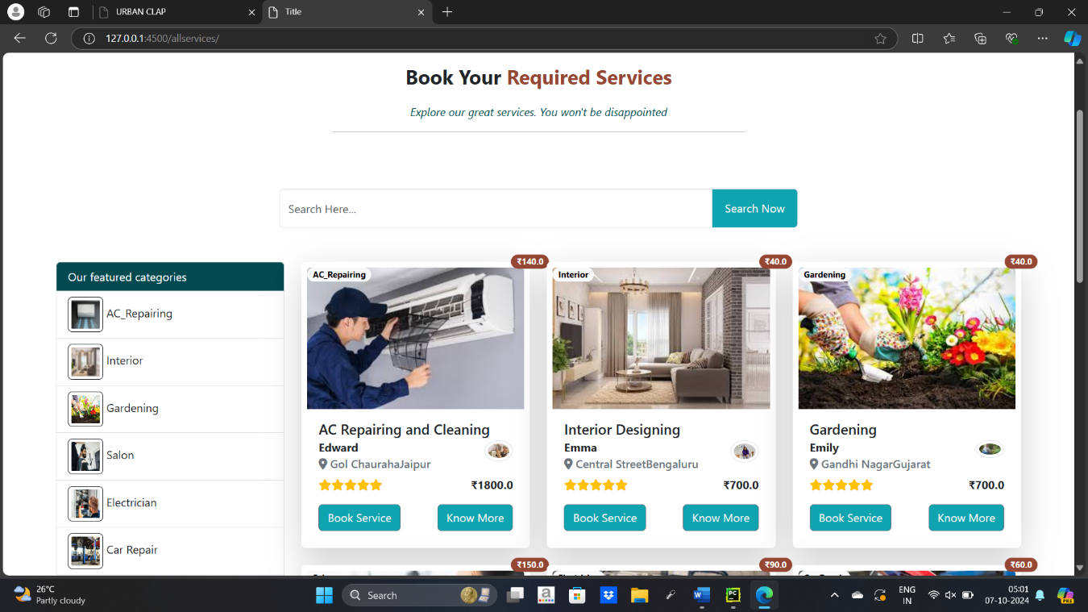

* Service

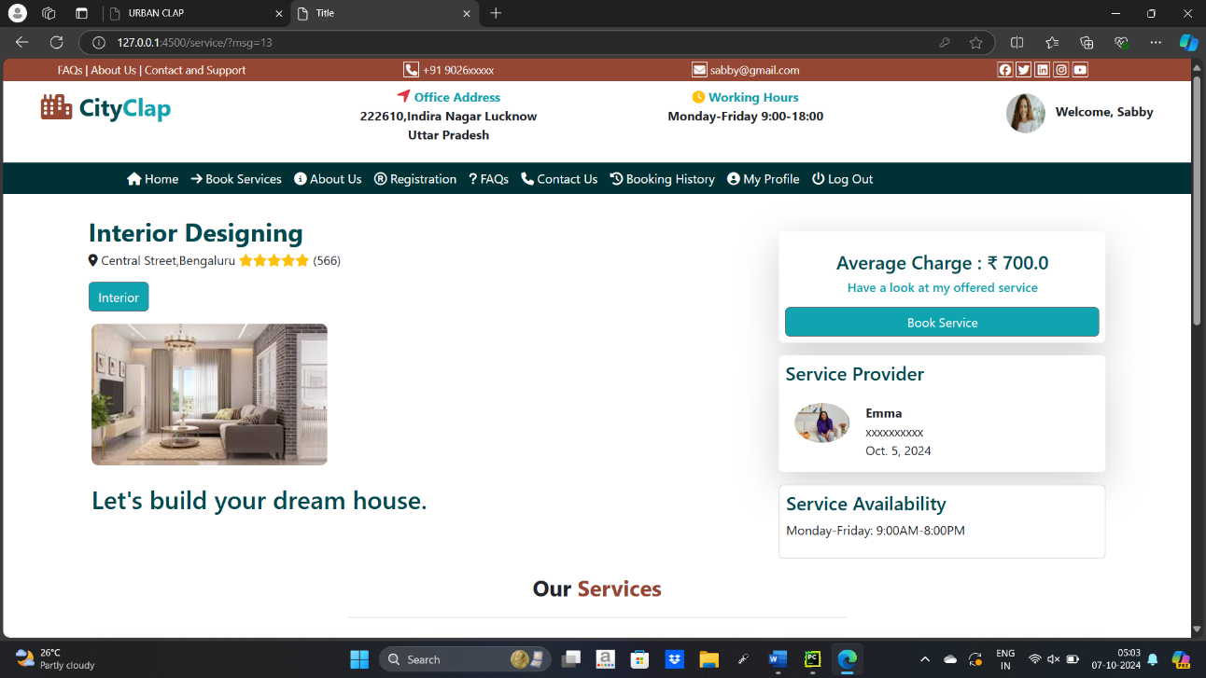

* Aboutus

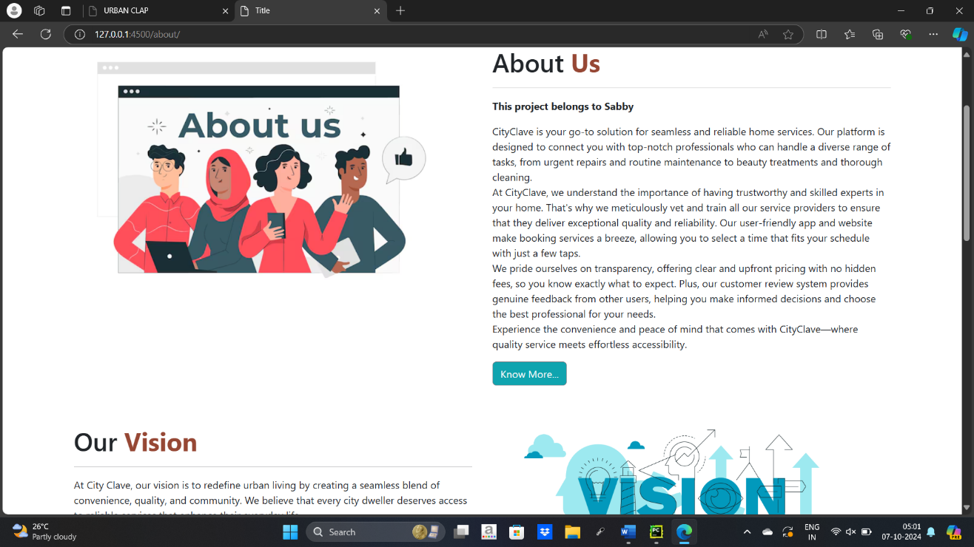

* Register

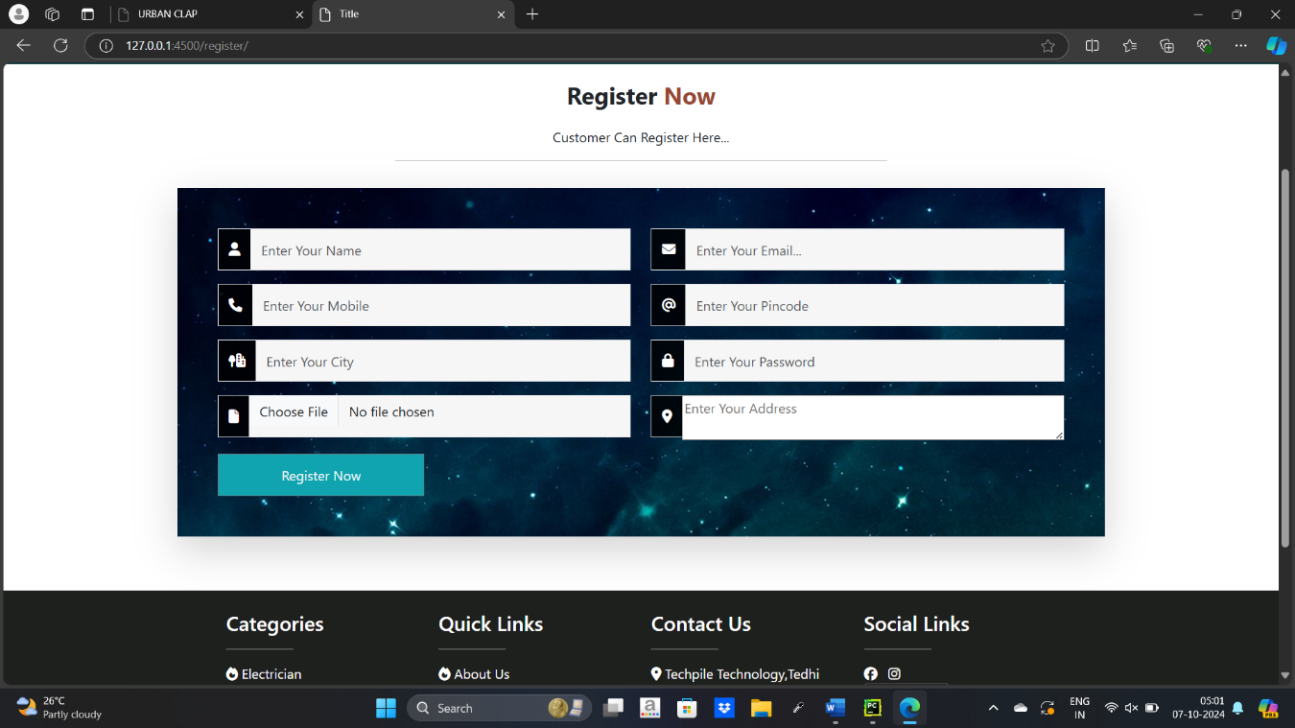

* Faqs

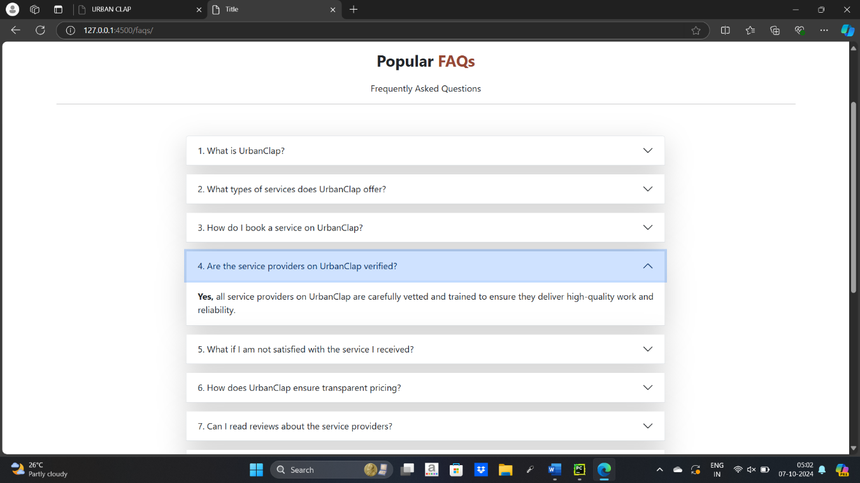

* Contactus

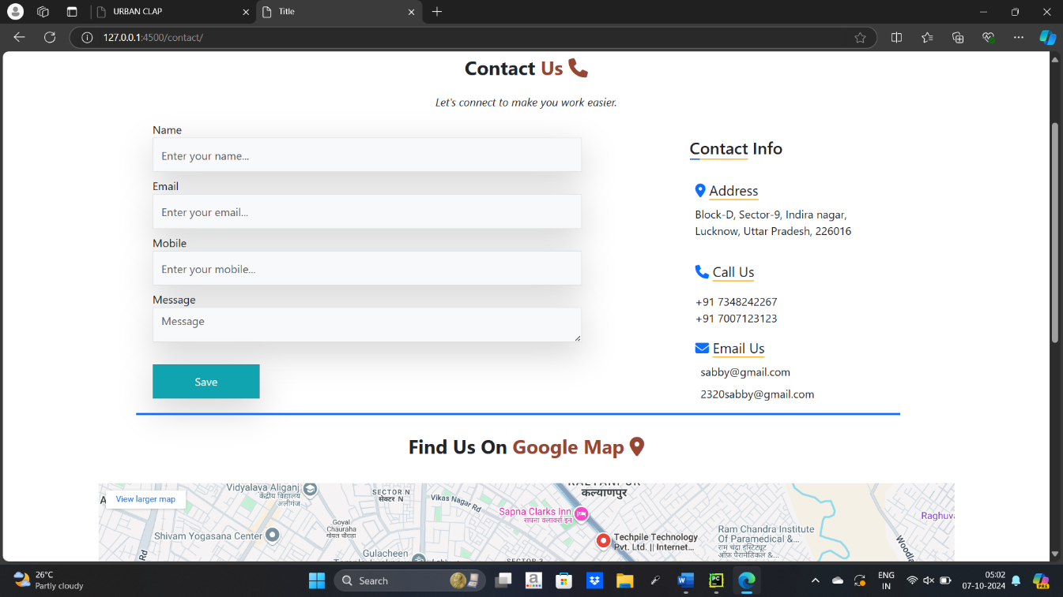

* Bookinghistory

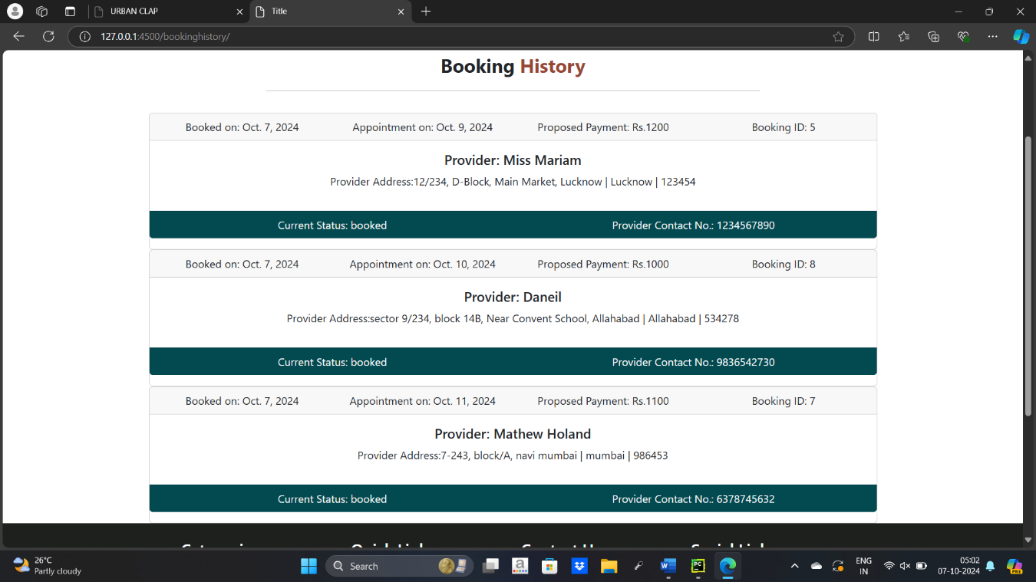

* Booking

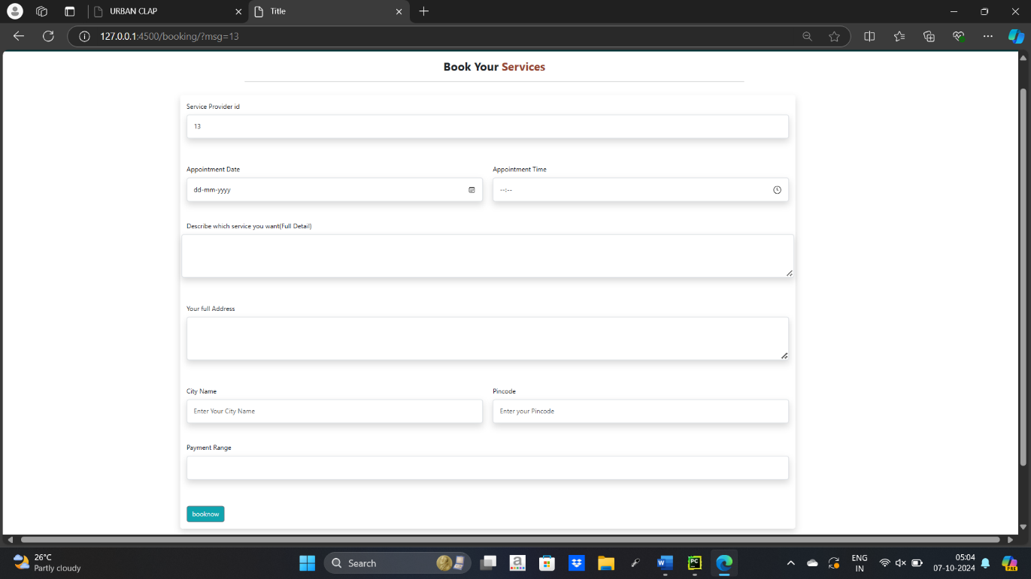

* Profile

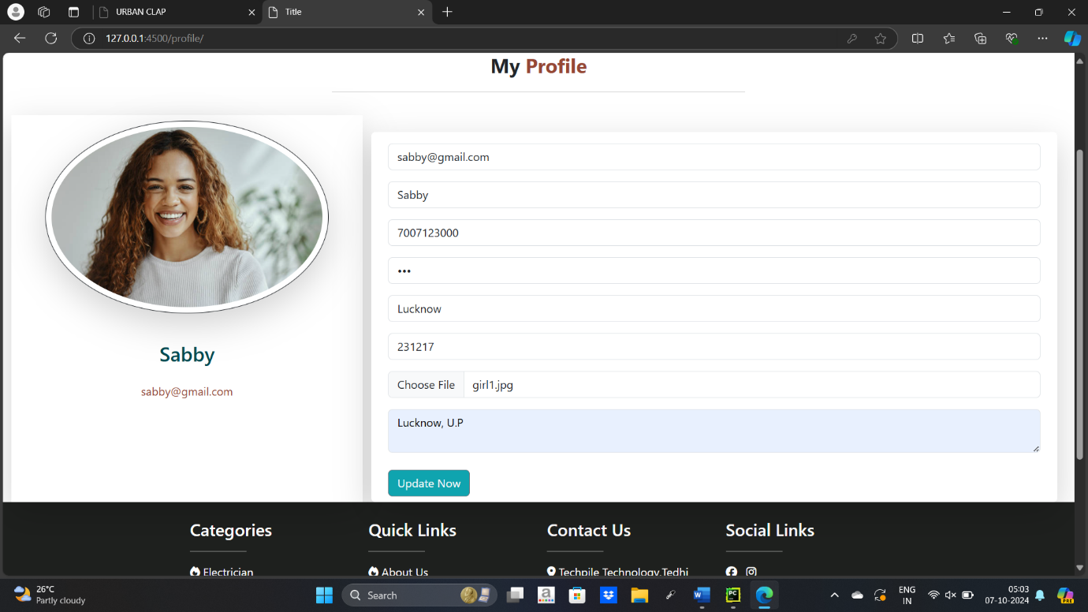

* + 1. **CODING**
* Base.html

<!DOCTYPE html>  
{% load static %}  
<html lang="en">  
<head>  
 <meta charset="UTF-8">  
 <title>Title</title>  
 <link href="{% static 'css/bootstrap.min.css' %}" rel="stylesheet"/>  
 <link href="{% static 'css/all.min.css' %}" rel="stylesheet"/>  
 <style>  
 :root  
 {  
 --bgcolor1:#003135;  
 --bgcolor2:#964734;  
 --bgcolor3:#024950;  
 --bgcolor4:#0FA4AF;  
 }  
 .bg-mycolor1  
 {  
 background:var(--bgcolor1);  
 }  
 .bg-mycolor2  
 {  
 background:var(--bgcolor2);  
 }  
 .bg-mycolor3  
 {  
 background:var(--bgcolor3);  
 }  
 .bg-mycolor4  
 {  
 background:var(--bgcolor4);  
 }  
 .txt-color1  
 {  
 color:var(--bgcolor1);  
 }  
 .txt-color2  
 {  
 color:var(--bgcolor2);  
 }  
 .txt-color3  
 {  
 color:var(--bgcolor3);  
 }  
 .txt-color4  
 {  
 color:var(--bgcolor4);  
 }  
 .t1 a  
 {  
 text-decoration:none;  
 color:white;  
 }  
 .t1  
 {  
 font-size:14px;  
 }   
 .ic  
 {  
 border:1px solid white;  
 height:20px;  
 width:20px;  
 text-align:center;  
 line-height:20px;  
 border-radius:1px;  
 transition:all .5s;  
 }  
 .ic:hover  
 {  
 border:1px solid var(--bgcolor3);  
 color:var(--bgcolor3);  
 transform:rotate(360deg);  
 transition:all .5s;  
 }  
 #menu  
 {  
 background:transparent !important;  
 }  
 #menu ul li a  
 {  
 color:white;  
 }  
 .ufooter  
 {  
 min-height:300px;  
 background:#1E201E;  
 }  
 .bfooter  
 {  
 background:#1E201E;  
 color:white;  
 text-align:center;  
 margin-top:2px;  
 }  
 .fr  
 {  
 color:white;  
 }  
 .imgzoom  
 {  
 transition:all ease 1s;  
 }  
 .imgzoom:hover  
 {  
 transform:scale(1.1);  
 transition:all ease 1s;  
 }  
 .ico  
 {  
 border-radius:50%;  
 border:1px solid black;  
  
 }  
 </style>  
</head>  
<body>  
<!-- start topbar-->  
<div class="container-fluid " >  
 <div class="row t1 bg-mycolor2 text-light text-center py-1">  
 <div class="col-sm-3">  
 <a href="/faqs/">FAQs</a> |  
 <a href="/about/">About Us</a> |  
 <a href="/contact/">Contact and Support</a>  
 </div>  
 <div class="col-sm-3">  
 <i class="fa-solid fa-phone ic"></i>  
 +91 9026xxxxx  
 </div>  
 <div class="col-sm-3">  
 <i class="fa-solid fa-envelope ic"></i>  
 {{request.session.email}}  
 </div>  
 <div class="col-sm-3">  
 <a href="#"><i class="fa-brands fa-facebook ic"></i></a>  
 <a href="#"><i class="fa-brands fa-twitter ic"></i></a>  
 <a href="#"><i class="fa-brands fa-linkedin ic"></i></a>  
 <a href="#"><i class="fa-brands fa-instagram ic"></i></a>  
 <a href="#"><i class="fa-brands fa-youtube ic"></i></a>  
 </div>  
 </div>  
 <div class="row t2 py-2">  
 <div class="col-sm-3 fs-2 ps-5">  
 <i class="fa-solid fa-city txt-color2 "></i>  
 <b style="font-size:30px;" class="txt-color3">City</b><b class="txt-color4" style="font-size:30px;">Clap</b>  
 </div>  
 <div class="col-sm-3 text-center">  
 <i class="fas fa-location-arrow text-danger fs-5"></i>  
 <b class="txt-color4">Office Address </b><br/>  
 <p>  
 <b>222610,Indira Nagar Lucknow <br />  
 Uttar Pradesh</b>  
 </p>  
 </div>  
 <div class="col-sm-3 text-center">  
 <i class="fas fa-clock text-warning"></i>  
 <b class="txt-color4">Working</b><b class="txt-color4"> Hours </b><br/>  
 <p><b>Monday-Friday 9:00-18:00</b></p>  
 </div>  
 <div class="col-sm-3 text-end pe-5 pt-2">  
 {% if not request.session.email %}  
 <img src="{% static 'images/urbanclap023.jpg' %}" height="50px" width="50px" style="border-radius:50%;"/> &nbsp;  
 {% else %}  
 <img src="/{{request.session.picture}}" height="50px" width="50px" style="border-radius:50%;"/> &nbsp;  
 <b>Welcome, {{request.session.name}}</b></div>  
 {% endif %}  
 </div>  
 <div class="row menu bg-mycolor1" style="min-height:40px;">  
 <div class="col-sm-1"></div>  
 <!-- end topbar-->  
 <!-- start menu -->  
 <div class="col-sm-10">  
 <nav class="navbar navbar-expand-lg bg-body-tertiary p-0" id="menu">  
 <div class="container-fluid">  
 <button class="navbar-toggler" type="button" data-bs-toggle="collapse" data-bs-target="#navbarSupportedContent" aria-controls="navbarSupportedContent" aria-expanded="false" aria-label="Toggle navigation">  
 <span class="navbar-toggler-icon"></span>  
 </button>  
 <div class="collapse navbar-collapse" id="navbarSupportedContent">  
 <ul class="navbar-nav me-auto mb-2 mb-lg-0">  
 <li class="nav-item">  
  
 <a class="nav-link active" aria-current="page" href="/home/">  
 <i class="fa-solid fa-house"></i>  
 Home</a>  
 </li>  
 <li class="nav-item">  
 <a class="nav-link" href="/allservices/">  
 <i class="fa-solid fa-arrow-right"></i>  
 Book Services</a>  
 </li>  
 <li class="nav-item">  
 <a class="nav-link" href="/about/">  
 <i class="fa-solid fa-circle-info"></i>  
 About Us</a>  
 </li>  
 <li class="nav-item">  
 <a class="nav-link" href="/register/">  
 <i class="fa-regular fa-registered"></i>  
 Registration</a>  
 </li>  
 <li class="nav-item">  
 <a class="nav-link" href="/faqs/">  
 <i class="fa-solid fa-question"></i>  
 FAQs</a>  
 </li>  
 <li class="nav-item">  
 <a class="nav-link" href="/contact/">  
 <i class="fa-solid fa-phone"></i>  
 Contact Us</a>  
 </li>  
 {% if not request.session.email %}  
 <li class="nav-item">  
 <a class="nav-link" href="/login/">  
 <i class="fa-solid fa-circle-user"></i>  
 Login</a>  
 </li>  
 {% else %}  
 <li class="nav-item">  
 <a class="nav-link" href="/bookinghistory/">  
 <i class="fa-solid fa-clock-rotate-left"></i>  
 Booking History</a>  
 </li>  
  
 <li class="nav-item">  
 <a class="nav-link" href="/profile/">  
 <i class="fa-solid fa-circle-user"></i>  
 My Profile</a>  
 </li>  
 <li class="nav-item">  
 <a class="nav-link" href="/logout/">  
 <i class="fa-solid fa-power-off"></i>  
 Log Out</a>  
 </li>  
 {% endif %}  
 </ul>  
 </div>  
 </div>  
</nav>  
 </div>  
 <!-- end menu -->  
 <div class="col-sm-1"></div>  
 </div>  
 <!--start slider-->  
 <div class="row slider" >  
 <div class="col-sm-12 " style="min-height:500px;">  
 {% block childpage %}  
  
 {% endblock %}  
 </div>  
 </div>  
 <!--end slider-->  
 <!---start footer-->  
 <div class="row ufooter">  
 <div class="col-sm-2"></div>  
 <div class="col-sm-2 fr"><br/>  
 <h4 class="txt-light">Categories</h4>  
 <hr style="background-color: white; width:80px; height: 2px;"/>  
 <li style="list-style-type:none;"><i class="fa-solid fa-fire"></i> Electrician</li>  
 <li style="list-style-type:none;"><i class="fa-solid fa-fire"></i> Gardening</li>  
 <li style="list-style-type:none;"><i class="fa-solid fa-fire"></i> Beauty</li>  
 <li style="list-style-type:none;"><i class="fa-solid fa-fire"></i> Repairing</li>  
 </div>  
 <div class="col-sm-2 fr"><br/>  
 <h4 class="txt-light">Quick Links</h4>  
 <hr style="background-color: white; width:80px; height: 2px;"/>  
 <a href="/about/" style="text-decoration:none; color:white;"><li style="list-style-type:none;"><i class="fa-solid fa-fire"></i> About Us</li></a>  
 <a href="/contact/" style="text-decoration:none; color:white;"><li style="list-style-type:none;"><i class="fa-solid fa-fire"></i> Contact Us</li></a>  
 <a href="/faqs/" style="text-decoration:none; color:white;"><li style="list-style-type:none;"><i class="fa-solid fa-fire"></i> FAQ</li></a>  
 <a href="#" style="text-decoration:none; color:white;"><li style="list-style-type:none;"><i class="fa-solid fa-fire"></i> Blog</li></a>  
 </div>  
 <div class="col-sm-2 fr"><br/>  
 <h4 class="txt-light">Contact Us</h4>  
 <hr style="background-color: white; width:80px; height: 2px;"/>  
 <a href="/contact/" style="text-decoration:none; color:white;"><li style="list-style-type:none;"><i class="fa-solid fa-location-dot"></i> Techpile Technology,Tedhi Pulia</li></a>  
 <li style="list-style-type:none;"><i class="fa-solid fa-phone"></i> 546382473</li>  
 <li style="list-style-type:none;"><i class="fa-solid fa-envelope"></i> sabby@gmail.com</li>  
 </div>  
 <div class="col-sm-2 fr"><br/>  
 <h4 class="txt-light">Social Links</h4>  
 <hr style="background-color: white; width:80px; height: 2px; "/>  
 <li style="list-style-type:none;">  
 <a href="#" style="text-decoration:none; color:white;"><i class="fa-brands fa-facebook "></i></a> &nbsp;  
 <a href="#" style="text-decoration:none; color:white;"><i class="fa-brands fa-instagram"> </i></a>  
 </li>  
 <li style="list-style-type:none;"></i>  
 <a href="https://play.google.com/store/games?device=windows"> <img src="{% static 'images/googleplay.png' %}" class="img-fluid" style="height:30px"/></a><br/>  
 <a href="https://www.apple.com/app-store/"> <img src="{% static 'images/appstore.png' %}" class="img-fluid" style="height:30px"/></a>  
 </li>  
 </div>  
 <div class="col-sm-2"></div>  
 </div>  
 <div class="row bfooter py-2">  
 <div class="col-sm-6"><b class="txt-color4">Developed By :</b> Saba Azim</div>  
 <div class="col-sm-6"><b class="txt-color4">Copyright to &copy;</b> <a href="https://www.techpile.in/" style="text-decoration:none; color:white;"> Techpile Technology Pvt. Ltd.</a></div>  
 </div>  
 </div>  
<!---end footer-->  
<script src="{% static 'js/bootstrap.bundle.js' %}"></script>  
</body>  
</html>

* Index.html

{% extends 'base.html' %}  
{% load static %}  
{% block childpage %}  
<style>  
 .imgzoom{  
 transition:all ease .5s;  
 }  
 .card-img-top:hover{  
 transform:scale(1.05);  
 }  
</style>  
 <!--start slider-->  
 <div id="carouselExampleCaptions" class="carousel slide carousel-fluid " data-bs-ride="carousel">  
 <div class="carousel-indicators">  
 <button type="button" data-bs-target="#carouselExampleCaptions" data-bs-slide-to="0" class="active" aria-current="true" aria-label="Slide 1"></button>  
 <button type="button" data-bs-target="#carouselExampleCaptions" data-bs-slide-to="1" aria-label="Slide 2"></button>  
 <button type="button" data-bs-target="#carouselExampleCaptions" data-bs-slide-to="2" aria-label="Slide 3"></button>  
 </div>  
 <div class="carousel-inner">  
 <div class="carousel-item active">  
 <img src="{% static 'images/slider2.png' %}" style="max-height:530px;" class="d-block w-100 " alt="..."/>  
<div class="carousel-caption d-none d-md-block">  
 <h5 style="color:#000000;font-size:30px;font-weight:bold;"> C i t y <i class="fa-regular fa-star"></i> C l a p</h5>  
 <p style="color:#000000">Your Service Expert</p>  
 </div>  
 </div>  
 <div class="carousel-item">  
 <img src="{% static 'images/urbanclap03.jpg' %}" style="max-height:530px;" class="d-block w-100 " alt="..."/>  
 <div class="carousel-caption d-none d-md-block">  
 <h5 style="font-size:30px;font-weight:bold;">Home service on Demand</h5>  
 <p></p>  
 </div>  
 </div>  
 <div class="carousel-item">  
 <img src="{% static 'images/slider1.png' %}" style="max-height:530px;" class="d-block w-100" alt="..."/>  
 <div class="carousel-caption d-none d-md-block">  
 <h5 style="font-size:30px;font-weight:bold;">India's largets Home service company</h5>  
 </div>  
 </div>  
 </div>  
 <button class="carousel-control-prev" type="button" data-bs-target="#carouselExampleCaptions" data-bs-slide="prev">  
 <span class="carousel-control-prev-icon" aria-hidden="true"></span>  
 <span class="visually-hidden">Previous</span>  
 </button>  
 <button class="carousel-control-next" type="button" data-bs-target="#carouselExampleCaptions" data-bs-slide="next">  
 <span class="carousel-control-next-icon" aria-hidden="true"></span>  
 <span class="visually-hidden">Next</span>  
 </button>  
</div>  
<!--end slider-->  
<!--category section starts-->  
 <div class="row category text-center py-3 my-4">  
 <div class="col-sm-1"></div>  
 <div class="col-sm-10 mx-auto">  
 <div class="fs-3"><b>Featured</b> <b class="txt-color2">Category</b></div>  
 <hr/>  
 <div class="row my-4">  
 {% for x in cdata %}  
 <!--start category 1-->  
 <div class="col-sm-3 mt-4">  
 <a href="/allservices?cid={{x.id}}" class="text-dark" style="text-decoration:none">  
 <p class="shadow p-3 mb-2 bg-body-tertiary rounded txt-center" >  
 <img src="../{{x.category_picture}}" class="img-fluid imgzoom" style="height:200px;width:200px;"/>  
 <b>{{x.category_name}}</b>  
 </p>  
 </a>  
 </div>  
 <!--end category 1-->  
 {% endfor %}  
 </div>  
 </div>  
 <div class="col-sm-1"></div>  
 </div>  
<!--category section ends-->  
<!--Most popular section starts-->  
<div class="container">  
 <div class="row heading text-center py-3">  
 <div class="col-sm-6 mx-auto ">  
 <p class="fs-3"><b><i class="fa-solid fa-fire text-warning"></i> Most </b><b class="txt-color2"> Popular Services</b></p>  
 <hr/>  
 </div>  
</div>  
 <div class="row section2 my-4">  
 {% for x in servicedata %}  
 <div class="col-sm-4 mb-4">  
 <div class="card mx-auto p-3 w-100 border-0 shadow-lg">  
 <span class="position-absolute top-0 start-100 translate-middle badge rounded-pill bg-mycolor2"> &#8377;{{x.discount_price}} <span class="visually-hidden">unread messages</span></span>  
 <img src="../{{x.service_picture}}" class="card-img-top imgzoom" height="200px" width="200px" alt="...">  
 <div class="position-absolute badge rounded-pill text-bg-light top-5 start-5">{{x.service_category}}</div>  
 <div class="card-body">  
 <h5 class="card-title">{{x.service_name}}</h5>  
 <h6 class="card-subtitle"><b>{{x.provider_name}}</b><img src="../{{x.provider_picture}}" height="40px" width="40px" class="img-thumbnail rounded-circle float-end" /></h6>  
 <h6 class="card-subtitle text-secondary py-2"><i class="fa-solid fa-location-dot"></i> {{x.address}}{{x.city}}</h6>  
 <div class="card-text text-warning"><i class="fa-solid fa-star"></i><i class="fa-solid fa-star"></i><i class="fa-solid fa-star"></i><i class="fa-solid fa-star"></i><i class="fa-solid fa-star"></i><b class="text-dark float-end"> &#8377;{{x.avg_price}}</b></div>  
 <div class="mt-3"><a href="/service?msg={{x.id}}" class="btn btn-outline-secondary bg-mycolor4 text-light">Book Service</a><a href="#" class="btn btn-outline-secondary bg-mycolor4 text-light float-end">Know More</a></div>  
 </div>  
</div>  
 </div>  
 {% endfor %}  
 </div>  
 </div>  
<!--most popular section ends-->  
<!--how it works section starts-->  
<div class="container">  
 <div class="row heading text-center py-3">  
 <div class="col-sm-6 mx-auto ">  
 <p class="fs-3"><b>How It</b><b class="txt-color2"> Works <i class="fa-solid fa-question"></i></b> </p>  
  
 <hr/>  
 </div>  
</div>  
<div class="container">  
<div class="row md-4">  
 <div class="col-sm-4 text-center mb-3">  
 <i class="fa-solid fa-map-marker-alt border border-1 rounded-3 fs-2 p-3 my-3 text-danger"></i>  
 <h2 class="txt-color1">Find Amazing Places</h2>  
 <p>Explore handpicked destinations and book your next getaway effortlessly.</p>  
 </div>  
 <div class="col-sm-4 text-center mb-3">  
 <i class="fa-solid fa-hand-holding-usd border border-1 rounded-3 fs-2 p-3 my-3 txt-color2"></i>  
 <h2 class="txt-color1">Book At Affordable Prices</h2>  
 <p>Choose from the best offers and book at reasonable prices with ease.</p>  
 </div>  
 <div class="col-sm-4 text-center mb-3">  
 <i class="fa-solid fa-smile border border-1 rounded-3 fs-2 p-3 my-3 text-warning"></i>  
 <h2 class="txt-color1">Safe & Secure</h2>  
 <p>Safety is our priority. Enjoy your trip with full assurance and security.</p>  
 </div>  
</div>  
 </div>  
 </div>  
<!--how it works section ends-->  
<!--Our services section starts-->  
<div class="container">  
 <div class="row heading text-center py-3">  
 <div class="col-sm-6 mx-auto ">  
 <p class="fs-3"><b>Our</b><b class="txt-color2"> Services</b></p>  
 </div>  
</div>  
 <div class="row section2 my-4">  
 <div class="col-sm-4 mb-4">  
 <div class="card mx-auto p-3 w-100 border-0 shadow-lg position-relative" style="width: 18rem;">  
 <img src="/static/images/urbanclap21.jpg" class="card-img-top imgzoom" alt="...">  
 <div class="position-absolute badge rounded-pill text-bg-light top-5 start-5">Car Wash</div>  
 <div class="card-body">  
 <h5 class="card-title">Car Repair Services</h5>  
 <h6 class="card-subtitle">Provider Name</h6>  
 <h6 class="card-subtitle text-secondary py-2"><i class="fa-solid fa-location-dot"></i> Lucknow</h6>  
 <div class="card-text text-warning"><i class="fa-solid fa-star"></i><i class="fa-solid fa-star"></i><i class="fa-solid fa-star"></i><i class="fa-solid fa-star"></i><i class="fa-solid fa-star"></i><b class="text-dark float-end"> ₹1999/-</b></div>  
 <div class="mt-3"><a href="/service/" class="btn btn-outline-secondary bg-mycolor4 text-light">Book Service</a><a href="#" class="btn btn-outline-secondary bg-mycolor4 text-light float-end">Know More</a></div>  
 </div>  
</div>  
 </div>  
 <div class="col-sm-4 mb-4">  
 <div class="card mx-auto p-3 w-100 border-0 shadow-lg position-relative" style="width: 18rem;">  
 <img src="/static/images/urbanclap21.jpg" class="card-img-top imgzoom" alt="...">  
 <div class="position-absolute badge rounded-pill text-bg-light top-5 start-5">Car Wash</div>  
 <div class="card-body">  
 <h5 class="card-title">Car Repair Services</h5>  
 <h6 class="card-subtitle">Provider Name</h6>  
 <h6 class="card-subtitle text-secondary py-2"><i class="fa-solid fa-location-dot"></i> Lucknow</h6>  
 <div class="card-text text-warning"><i class="fa-solid fa-star"></i><i class="fa-solid fa-star"></i><i class="fa-solid fa-star"></i><i class="fa-solid fa-star"></i><i class="fa-solid fa-star"></i><b class="text-dark float-end"> ₹1999/-</b></div>  
 <div class="mt-3"><a href="#" class="btn btn-outline-secondary bg-mycolor4 text-light">Book Service</a><a href="#" class="btn btn-outline-secondary bg-mycolor4 text-light float-end">Know More</a></div>  
 </div>  
</div>  
 </div>  
 <div class="col-sm-4 mb-4">  
 <div class="card mx-auto p-3 w-100 border-0 shadow-lg position-relative" style="width: 18rem;">  
 <img src="/static/images/urbanclap21.jpg" class="card-img-top imgzoom" alt="...">  
 <div class="position-absolute badge rounded-pill text-bg-light top-5 start-5">Car Wash</div>  
 <div class="card-body">  
 <h5 class="card-title">Car Repair Services</h5>  
 <h6 class="card-subtitle">Provider Name</h6>  
 <h6 class="card-subtitle text-secondary py-2"><i class="fa-solid fa-location-dot"></i> Lucknow</h6>  
 <div class="card-text text-warning"><i class="fa-solid fa-star"></i><i class="fa-solid fa-star"></i><i class="fa-solid fa-star"></i><i class="fa-solid fa-star"></i><i class="fa-solid fa-star"></i><b class="text-dark float-end"> ₹1999/-</b></div>  
 <div class="mt-3"><a href="#" class="btn btn-outline-secondary bg-mycolor4 text-light">Book Service</a><a href="#" class="btn btn-outline-secondary bg-mycolor4 text-light float-end">Know More</a></div>  
 </div>  
</div>  
 </div>  
 </div>  
 </div>  
<!--Our services section ends-->  
 <div class="row section3"></div>  
 <div class="row section4"></div>  
{% endblock %}

* Service.html

{% extends 'base.html' %}  
{% load static %}  
  
{% block childpage %}  
  
{% for x in sdata %}  
  
<div class="container">  
 <div class="row">  
 <div class="col-sm-8">  
 <div class="row heading pt-4">  
 <div class="col-sm-6">  
 <p class="fs-2 m-0 txt-color3"><b>{{x.service_name}}</b></p>  
 <p class="m-0"><i class="fa-solid fa-location-dot"></i> {{x.address | safe }},{{x.city}} <i class="fa-solid fa-star text-warning"></i><i class="fa-solid fa-star text-warning"></i><i class="fa-solid fa-star text-warning"></i><i class="fa-solid fa-star text-warning"></i><i class="fa-solid fa-star text-warning"></i> (566)</p>  
 <div><a class="btn btn-outline-secondary bg-mycolor4 text-light mt-3 ">{{x.service_category}}</a></div>  
 </div>  
</div>  
 <div class="row">  
 <div class="col-sm-12 p-3">  
 <img src="../{{x.service_picture}}" style="max-height:300px;max-width:300px" class="img-fluid w-100 rounded-3"/>  
 <br/><br/><h2 class="txt-color3" >{{x.details}}</h2>  
 </div>  
 </div>  
 </div>  
 <div class="col-sm-4">  
 <div class="card mt-5 text-center border-0 shadow-lg">  
 <h4 class="mt-4 txt-color3"> Average Charge : &#8377; {{x.avg_price}}</h4>  
 <h6><a href="#offeredservices" class="mt-2 txt-color4 " style="text-decoration:none;">Have a look at my offered service</a></h6>  
 <a href="/booking?msg={{x.id}}" class="btn btn-outline-secondary bg-mycolor4 text-light m-2">Book Service</a>  
 </div>  
 <div class="card mt-3 border-0 shadow-lg">  
 <h4 class="mt-2 mx-2 txt-color3">Service Provider</h4>  
 <div class="row">  
 <div class="col-3 p-3">  
 <img src="../{{x.provider_picture}}" style="max-height:70px;max-width:70px" class="img-fluid rounded-circle ms-3"/>  
 </div>  
 <div class="col-9 py-3">  
 <b class="mt-0">{{ x.provider_name}}</b>  
 <p class="m-0" style="">xxxxxxxxxx</p>  
 <p class="m-0">{{x.added_date}}</p>  
 </div>  
 </div>  
 </div>  
 <div class="card mt-3 p-2 ">  
 <h4 class="txt-color3">Service Availability</h4>  
 {{x.availability | safe }}  
 </div>  
 </div>  
 </div>  
  
 <!--display all service provider in a table-->  
 <div class="row" id="offeredservices">  
 {% for s in services %}  
 <div class="col-sm-4 m-2">  
 <div class="card">  
 <div class="card-header">  
 {{s.service_title}}  
 </div>  
 <div class="card-body">  
 <div class="row"><div class="col-sm-8">  
 <p class="card-text">{{s.description}}</p>  
 <h6 class="card-title">Charge: {{s.cost}}</h6>  
 <h6 class="card-text">Approx Time : {{s.avg_time}}</h6>  
 </div>  
 <div class="col-sm-4">  
 <img src="../{{s.service_pic}}" height="100%" width="100%"/>  
 </div>  
 </div>  
 </div>  
</div>  
 </div>  
 {% endfor %}  
 </div>  
 <!--display all service provider in a table ended-->  
  
</div>  
<!--Our services section starts-->  
<div class="container">  
 <div class="row heading text-center py-3">  
 <div class="col-sm-6 mx-auto ">  
 <p class="fs-3"><b>Our</b><b class="txt-color2"> Services</b> </p>  
 <hr/>  
 </div>  
</div>  
 <div class="row section2 my-4">  
 <div class="col-sm-4 mb-4">  
 <div class="card mx-auto p-3 w-100 border-0 shadow-lg position-relative" style="width: 18rem;">  
 <img src="{% static 'images/urbanclap21.jpg' %}" class="card-img-top imgzoom" alt="...">  
 <div class="position-absolute badge rounded-pill text-bg-light top-5 start-5">Car Wash</div>  
 <div class="card-body">  
 <h5 class="card-title">Car Repair Services</h5>  
 <h6 class="card-subtitle">Provider Name</h6>  
 <h6 class="card-subtitle text-secondary py-2"><i class="fa-solid fa-location-dot"></i> Lucknow</h6>  
 <div class="card-text text-warning"><i class="fa-solid fa-star"></i><i class="fa-solid fa-star"></i><i class="fa-solid fa-star"></i><i class="fa-solid fa-star"></i><i class="fa-solid fa-star"></i><b class="text-dark float-end"> &#8377;1999/-</b></div>  
 <div class="mt-3"><a href="/service/" class="btn btn-outline-secondary bg-mycolor4 text-light">Book Service</a><a href="#" class="btn btn-outline-secondary bg-mycolor4 text-light float-end">Know More</a></div>  
 </div>  
</div>  
 </div>  
 <div class="col-sm-4 mb-4">  
 <div class="card mx-auto p-3 w-100 border-0 shadow-lg position-relative" style="width: 18rem;">  
 <img src="{% static 'images/urbanclap21.jpg' %}" class="card-img-top imgzoom" alt="...">  
 <div class="position-absolute badge rounded-pill text-bg-light top-5 start-5">Car Wash</div>  
 <div class="card-body">  
 <h5 class="card-title">Car Repair Services</h5>  
 <h6 class="card-subtitle">Provider Name</h6>  
 <h6 class="card-subtitle text-secondary py-2"><i class="fa-solid fa-location-dot"></i> Lucknow</h6>  
 <div class="card-text text-warning"><i class="fa-solid fa-star"></i><i class="fa-solid fa-star"></i><i class="fa-solid fa-star"></i><i class="fa-solid fa-star"></i><i class="fa-solid fa-star"></i><b class="text-dark float-end"> &#8377;1999/-</b></div>  
 <div class="mt-3"><a href="#" class="btn btn-outline-secondary bg-mycolor4 text-light">Book Service</a><a href="#" class="btn btn-outline-secondary bg-mycolor4 text-light float-end">Know More</a></div>  
 </div>  
</div>  
 </div>  
 <div class="col-sm-4 mb-4">  
 <div class="card mx-auto p-3 w-100 border-0 shadow-lg position-relative" style="width: 18rem;">  
 <img src="{% static 'images/urbanclap21.jpg' %}" class="card-img-top imgzoom" alt="...">  
 <div class="position-absolute badge rounded-pill text-bg-light top-5 start-5">Car Wash</div>  
 <div class="card-body">  
 <h5 class="card-title">Car Repair Services</h5>  
 <h6 class="card-subtitle">Provider Name</h6>  
 <h6 class="card-subtitle text-secondary py-2"><i class="fa-solid fa-location-dot"></i> Lucknow</h6>  
 <div class="card-text text-warning"><i class="fa-solid fa-star"></i><i class="fa-solid fa-star"></i><i class="fa-solid fa-star"></i><i class="fa-solid fa-star"></i><i class="fa-solid fa-star"></i><b class="text-dark float-end"> &#8377;1999/-</b></div>  
 <div class="mt-3"><a href="#" class="btn btn-outline-secondary bg-mycolor4 text-light">Book Service</a><a href="#" class="btn btn-outline-secondary bg-mycolor4 text-light float-end">Know More</a></div>  
 </div>  
</div>  
 </div>  
 </div>  
 </div>  
<!--Our services section ends-->  
{% endfor %}  
{% endblock %}

* Allservices.html

{% extends 'base.html' %}  
{% load static %}  
{% block childpage %}  
<!--start heading-->  
<div class="row m-3">  
 <div class="col-sm-5 mx-auto text-center">  
 <p class="fs-3"><b>Book Your </b><b class="txt-color2"> Required Services</b> </p>  
 <i class="txt-color3">Explore our great services. You won't be disappointed</i>  
 <hr/>  
 </div>  
</div>  
<!--end heading-->  
<div class="row">  
 <div class="col-sm-6 mx-auto my-5">  
 <form>  
 <div class="input-group">  
 <input type="text" name="search" class="form-control" placeholder="Search Here..." style="height:55px;" />  
 <i class="input-group-text bg-mycolor4 ">  
 <input type="submit" value="Search Now" style="background:transparent;border:none;color:white;"/>  
 </i>  
 </div>  
 </form>  
 </div>  
 <div class="col-sm-11 mx-auto">  
 <div class="row">  
 <div class="col-sm-3">  
 <ul class="list-group">  
 <li class="list-group-item bg-mycolor3 text-light">Our featured categories</li>  
 {% for i in cdata %}  
 <li class="list-group-item imgzoom ">  
 <img src="../{{i.category_picture}}" height="50px" width="50px" class="rounded border border-dark p-1"/>  
 <a href="/allservices?cid={{i.id}}" style="text-decoration:none;" class="text-dark"> {{i.category_name}}</a>  
 </li>  
 {% endfor %}  
 </ul>  
 </div>  
 <div class="col-sm-9">  
 <div class="row">  
 {% for x in servicedata %}  
 <div class="col-sm-4 mb-4">  
 <div class="card position-relative mx-auto p-2 w-100 border-0 shadow-lg " >  
 <span class="position-absolute top-0 start-100 translate-middle badge rounded-pill bg-mycolor2"> &#8377;{{x.discount_price}} <span class="visually-hidden">unread messages</span></span>  
 <img src="../{{x.service_picture}}" class="card-img-top imgzoom" height="200px" width="200px" alt="...">  
 <div class="position-absolute badge rounded-pill text-bg-light top-5 start-5">{{x.service_category}}</div>  
 <div class="card-body">  
 <h5 class="card-title">{{x.service_name}}</h5>  
 <h6 class="card-subtitle"><b>{{x.provider_name}}</b><img src="../{{x.provider_picture}}" height="40px" width="40px" class="img-thumbnail rounded-circle float-end" /></h6>  
 <h6 class="card-subtitle text-secondary py-2"><i class="fa-solid fa-location-dot"></i> {{x.address}}{{x.city}}</h6>  
 <div class="card-text text-warning"><i class="fa-solid fa-star"></i><i class="fa-solid fa-star"></i><i class="fa-solid fa-star"></i><i class="fa-solid fa-star"></i><i class="fa-solid fa-star"></i><b class="text-dark float-end"> &#8377;{{x.avg_price}}</b></div>  
 <div class="mt-3"><a href="/service?msg={{x.id}}" class="btn btn-outline-secondary bg-mycolor4 text-light">Book Service</a><a href="/service?msg={{ x.id }}" class="btn btn-outline-secondary bg-mycolor4 text-light float-end">Know More</a></div>  
 </div>  
</div>  
 </div>  
 {% endfor %}  
 </div>  
 </div>  
 </div>  
 </div>  
</div>  
{% endblock %}

* About.html

{% extends 'base.html' %}  
{% load static %}  
{% block childpage %}  
<div class="container">  
 <div class="row my-5">  
 <div class="col-sm-6">  
 <img src="{% static 'images/aboutus.png' %}" height="400" width="600" class="img-fluid"/>  
 </div>  
 <div class="col-sm-6 px-3">  
 <h1 class="my-3">About<b class="txt-color2"> Us</b></h1><hr/>  
 <p><b>This project belongs to Sabby </b></p>  
 <p>CityClave is your go-to solution for seamless and reliable home services. Our platform is designed to connect you with top-notch professionals who can handle a diverse range of tasks, from urgent repairs and routine maintenance to beauty treatments and thorough cleaning.<br/>  
At CityClave, we understand the importance of having trustworthy and skilled experts in your home. That's why we meticulously vet and train all our service providers to ensure that they deliver exceptional quality and reliability. Our user-friendly app and website make booking services a breeze, allowing you to select a time that fits your schedule with just a few taps.<br/>  
We pride ourselves on transparency, offering clear and upfront pricing with no hidden fees, so you know exactly what to expect. Plus, our customer review system provides genuine feedback from other users, helping you make informed decisions and choose the best professional for your needs.<br/>  
Experience the convenience and peace of mind that comes with CityClave—where quality service meets effortless accessibility.  
 </p>  
 <a class="btn btn-outline-secondary bg-mycolor4 text-light" href="#">Know More...</a>  
 </div>  
 </div>  
 <div class="row my-5">  
 <div class="col-sm-6 px-3">  
 <h1 class="my-3">Our<b class="txt-color2"> Vision</b></h1>  
 <hr/>  
At City Clave, our vision is to redefine urban living by creating a seamless blend of convenience, quality, and community. We believe that every city dweller deserves access to reliable services that enhance their everyday life.  
 <p ><b> Key Elements of Our Vision:</b></p>  
 <li class="txt-color2">Empowerment through Convenience</li>  
We envision a world where individuals can easily access essential services, freeing up time for what truly matters. Our platform connects customers with trusted professionals, simplifying daily tasks and enhancing life’s experiences.  
<br/><li class="txt-color2">Quality and Trust</li>  
Our commitment to quality is unwavering. We strive to set the highest standards in service delivery, ensuring that every interaction builds trust and satisfaction. Each professional in our network is thoroughly vetted and trained to provide top-notch service.  
<br/><li class="txt-color2">Community-Centric Approach</li>  
We believe in the power of community. Our vision is to foster strong local connections by supporting small businesses and skilled professionals. By prioritizing community engagement, we aim to create a vibrant ecosystem where everyone thrives.  
<br/><li class="txt-color2">Sustainability and Innovation</li>  
Urban living must be sustainable. We are dedicated to implementing eco-friendly practices and innovative solutions that minimize our environmental impact. Our vision includes leveraging technology to create smarter, more sustainable urban environments.  
<br/><li class="txt-color2">Enhancing Quality of Life</li>  
Ultimately, our goal is to enhance the quality of life for urban residents. By providing accessible services that cater to diverse needs, we aim to create a happier, healthier, and more fulfilling urban experience.  
<br/><li class="txt-color2">Join Us on Our Journey</li>  
As we work towards this vision, we invite you to join us. Whether you’re a customer seeking services or a professional looking to make a difference, together we can build a better urban future.</p>  
 <a class="btn btn-outline-secondary bg-mycolor4 text-light" href="#">Know More...</a>  
 </div>  
 <div class="col-sm-6">  
 <img src="{% static 'images/vision.png' %}" height="400" width="600" class="img-fluid"/>  
 </div>  
 </div>  
 <div class="row heading text-center py-3">  
 <div class="col-sm-6 mx-auto ">  
 <p class="fs-3"><b>Our</b><b class="txt-color2"> Achievements</b> <i class="fa-solid fa-trophy txt-color2"></i></p>  
 <hr/>  
 </div>  
</div>  
 <div class="row mb-4">  
 <div class="col-sm-3 text-center mb-4">  
 <i class="fa-solid fa-screwdriver-wrench fs-3 ico p-3 text-primary"></i>  
 <h2 class="mt-3 txt-color2">1000+ </h2>  
 <h5 class="txt-color3">Successful Services Delivered.</h5>  
 </div>  
 <div class="col-sm-3 text-center mb-4">  
 <i class="fa-solid fa-face-smile fs-3 ico p-3 text-warning"></i>  
 <h2 class="mt-3 txt-color2">500+ </h2>  
 <h5 class="txt-color3">Happy Customers</h5>  
 </div>  
 <div class="col-sm-3 text-center mb-4">  
 <i class="fa-solid fa-star fs-3 ico p-3 text-warning"></i>  
 <h2 class="mt-3 txt-color2">2000+ </h2>  
 <h5 class="txt-color3">5 Star Rating</h5>  
 </div>  
 <div class="col-sm-3 text-center mb-4">  
 <i class="fa-solid fa-registered fs-3 ico p-3 text-success"></i>  
 <h2 class="mt-3 txt-color2">5000+ </h2>  
 <h5 class="txt-color3">Services Registered</h5>  
 </div>  
 </div>  
</div>  
{% endblock %}

* Register.html

{% extends 'base.html' %}  
{% load static %}  
{% block childpage %}  
<style>  
 .form-control  
 {  
 height:50px;  
 background:#f6f6f6;  
 border-radius:0px !important;  
 }  
 .input-group-text  
 {  
 height:50px;  
 color:white;  
 border-radius:0px !important;  
 background:rgba(0,0,0,.8);  
 }  
</style>  
<body>  
<!--start heading-->  
<div class="row m-3 ">  
 <div class="col-sm-5 mx-auto text-center ">  
 <p class="fs-3"><b>Register </b><b class="txt-color2"> Now </b> </p>  
 <p>Customer Can Register Here...</p>  
 <hr/>  
 </div>  
</div>  
<!--end heading-->  
<div >  
<div class="container my-3">  
 <div class="row ">  
 <div class="col-sm-1"></div>  
 <div class="col-sm-10 p-5 mb-5 shadow-lg " style="background-image:url('{% static 'images/back1.jpg' %}');">  
 <form method="post" autocomplete="off" enctype="multipart/form-data">  
 {% csrf_token %}  
 <div class="row">  
 <div class="col-sm-6 ">  
 <div class="input-group flex-nowrap">  
 <span class="input-group-text" ><i class="fa-solid fa-user"></i></span>  
 <input name="name" type="text" class="form-control" placeholder="Enter Your Name" aria-label="Username" aria-describedby="addon-wrapping">  
 </div>  
 </div>  
 <div class="col-sm-6">  
 <div class="input-group flex-nowrap">  
 <span class="input-group-text"><i class="fa-solid fa-envelope"></i></span>  
 <input name="email" type="email" class="form-control" placeholder="Enter Your Email..." aria-label="Username" aria-describedby="addon-wrapping">  
 </div>  
 </div>  
 </div>  
 <div class="row mt-3">  
 <div class="col-sm-6">  
 <div class="input-group flex-nowrap">  
 <span class="input-group-text" ><i class="fa-solid fa-phone"></i></span>  
 <input name="mobile" type="number" class="form-control" placeholder="Enter Your Mobile" aria-label="Username" aria-describedby="addon-wrapping">  
 </div>  
 </div>  
 <div class="col-sm-6">  
 <div class="input-group flex-nowrap">  
 <span class="input-group-text" ><i class="fa-solid fa-at"></i></span>  
 <input name="pincode" type="number" class="form-control" placeholder="Enter Your Pincode" aria-label="Username" aria-describedby="addon-wrapping">  
 </div>  
 </div>  
 </div>  
 <div class="row mt-3">  
 <div class="col-sm-6">  
 <div class="input-group flex-nowrap">  
 <span class="input-group-text" ><i class="fa-solid fa-tree-city"></i></span>  
 <input name="city" type="text" class="form-control" placeholder="Enter Your City" aria-label="Username" aria-describedby="addon-wrapping">  
 </div>  
 </div>  
 <div class="col-sm-6">  
 <div class="input-group flex-nowrap">  
 <span class="input-group-text" ><i class="fa-solid fa-lock"></i></span>  
 <input name="password" type="password" class="form-control" placeholder="Enter Your Password" aria-label="Username" aria-describedby="addon-wrapping">  
 </div>  
 </div>  
 </div>  
 <div class="row mt-3">  
 <div class="col-sm-6">  
 <div class="input-group flex-nowrap">  
 <span class="input-group-text" ><i class="fa-solid fa-file"></i></span>  
 <input name="fu" type="file" class="form-control" >  
 </div>  
 </div>  
 <div class="col-sm-6">  
 <div class="input-group flex-nowrap">  
 <span class="input-group-text" ><i class="fa-solid fa-location-dot"></i></span>  
 <textarea name="address" class="w-100" placeholder="Enter Your Address"></textarea>  
 </div>  
 </div>  
 </div>  
 <div class="row mt-3">  
 <div class="col-sm-6">  
 <input type="submit" value="Register Now" class="form-control text-light w-50 btn btn-outline-secondary " style="background:var(--bgcolor4) !important"/>  
 </div>  
 </div>  
 </form>  
 </div>  
 <div class="col-sm-2"></div>  
 </div>  
</div>  
 </div>  
</body>  
{% endblock %}

* Faqs.html

{% extends 'base.html' %}  
{% load static %}  
{% block childpage %}  
<div class="container">  
 <div class="row my-4">  
 <div class="fs-3 text-center"><p><b>Popular</b> <b class="txt-color2">FAQs</b></p></div>  
 <p class="text-center">Frequently Asked Questions</p>  
 <hr/>  
 <div class="col-sm-2 my-4"></div>  
 <div class="col-sm-8 my-4">  
 <div class="accordion" id="accordionExample">  
 <div class="accordion-item mt-3 shadow-lg">  
 <h2 class="accordion-header">  
 <button class="accordion-button" type="button" data-bs-toggle="collapse" data-bs-target="#collapseOne" aria-expanded="true" aria-controls="collapseOne">  
 1. What is UrbanClap?  
 </button>  
 </h2>  
 <div id="collapseOne" class="accordion-collapse collapse show" data-bs-parent="#accordionExample">  
 <div class="accordion-body">  
 <strong> UrbanClap</strong> is a platform that connects users with a wide range of home service professionals, including repair technicians, beauticians, and cleaners, making it easy to book reliable services for your home and personal needs.  
 </div>  
 </div>  
 </div>  
 <div class="accordion-item mt-3 shadow-lg">  
 <h2 class="accordion-header">  
 <button class="accordion-button collapsed" type="button" data-bs-toggle="collapse" data-bs-target="#collapseTwo" aria-expanded="false" aria-controls="collapseTwo">  
 2. What types of services does UrbanClap offer?  
 </button>  
 </h2>  
 <div id="collapseTwo" class="accordion-collapse collapse" data-bs-parent="#accordionExample">  
 <div class="accordion-body">  
 <strong>UrbanClap</strong> offers a comprehensive list of services, including plumbing, electrical repairs, beauty treatments, cleaning,Fitness & Wellness , and more.  
 </div>  
 </div>  
 </div>  
 <div class="accordion-item mt-3 shadow-lg">  
 <h2 class="accordion-header">  
 <button class="accordion-button collapsed" type="button" data-bs-toggle="collapse" data-bs-target="#collapseThree" aria-expanded="false" aria-controls="collapseThree">  
 3. How do I book a service on UrbanClap?  
 </button>  
 </h2>  
 <div id="collapseThree" class="accordion-collapse collapse" data-bs-parent="#accordionExample">  
 <div class="accordion-body">  
 You can book a service through our user-friendly app or website by selecting the service you need, choosing a professional, and scheduling a time that suits your convenience.  
 </div>  
 </div>  
 </div>  
 <div class="accordion-item mt-3 shadow-lg">  
 <h2 class="accordion-header">  
 <button class="accordion-button collapsed" type="button" data-bs-toggle="collapse" data-bs-target="#collapseFour" aria-expanded="false" aria-controls="collapseFour">  
 4. Are the service providers on UrbanClap verified?  
 </button>  
 </h2>  
 <div id="collapseFour" class="accordion-collapse collapse" data-bs-parent="#accordionExample">  
 <div class="accordion-body">  
 <strong>Yes, </strong>all service providers on UrbanClap are carefully vetted and trained to ensure they deliver high-quality work and reliability.  
 </div>  
 </div>  
 </div>  
 <div class="accordion-item mt-3 shadow-lg">  
 <h2 class="accordion-header">  
 <button class="accordion-button collapsed" type="button" data-bs-toggle="collapse" data-bs-target="#collapseFive" aria-expanded="false" aria-controls="collapseFive">  
 5. What if I am not satisfied with the service I received?  
 </button>  
 </h2>  
 <div id="collapseFive" class="accordion-collapse collapse" data-bs-parent="#accordionExample">  
 <div class="accordion-body">  
 If you’re not satisfied with the service, please contact our customer support team. We offer a satisfaction guarantee and will work to resolve any issues or provide a refund if necessary.  
 </div>  
 </div>  
 </div>  
 <div class="accordion-item mt-3 shadow-lg">  
 <h2 class="accordion-header">  
 <button class="accordion-button collapsed" type="button" data-bs-toggle="collapse" data-bs-target="#collapseSix" aria-expanded="false" aria-controls="collapseSix">  
 6. How does UrbanClap ensure transparent pricing?  
 </button>  
 </h2>  
 <div id="collapseSix" class="accordion-collapse collapse" data-bs-parent="#accordionExample">  
 <div class="accordion-body">  
 <strong>UrbanClap </strong>offers clear and upfront pricing with no hidden fees. The cost of services is communicated to you before you confirm your booking.  
 </div>  
 </div>  
 </div>  
 <div class="accordion-item mt-3 shadow-lg">  
 <h2 class="accordion-header">  
 <button class="accordion-button collapsed" type="button" data-bs-toggle="collapse" data-bs-target="#collapseSeven" aria-expanded="false" aria-controls="collapseSeven">  
 7. Can I read reviews about the service providers?  
 </button>  
 </h2>  
 <div id="collapseSeven" class="accordion-collapse collapse" data-bs-parent="#accordionExample">  
 <div class="accordion-body">  
 <strong>Yes, </strong>UrbanClap features genuine reviews from other users to help you make informed decisions about which service provider to choose.  
 </div>  
 </div>  
 </div>  
 <div class="accordion-item mt-3 shadow-lg">  
 <h2 class="accordion-header">  
 <button class="accordion-button collapsed" type="button" data-bs-toggle="collapse" data-bs-target="#collapseEight" aria-expanded="false" aria-controls="collapseEight">  
 8. Are there any additional charges for booking through UrbanClap?  
 </button>  
 </h2>  
 <div id="collapseEight" class="accordion-collapse collapse" data-bs-parent="#accordionExample">  
 <div class="accordion-body">  
 <strong>No, </strong> UrbanClap charges no additional fees beyond the quoted price for the service. All costs are clearly outlined before you finalize your booking.  
 </div>  
 </div>  
 </div>  
 <div class="accordion-item mt-3 shadow-lg">  
 <h2 class="accordion-header">  
 <button class="accordion-button collapsed" type="button" data-bs-toggle="collapse" data-bs-target="#collapseNine" aria-expanded="false" aria-controls="collapseNine">  
 9. Can I choose a specific service provider?  
 </button>  
 </h2>  
 <div id="collapseNine" class="accordion-collapse collapse" data-bs-parent="#accordionExample">  
 <div class="accordion-body">  
 <strong>Yes, </strong>you can select a specific service provider based on their profile, ratings, and reviews available on the platform.\  
 </div>  
 </div>  
 </div>  
 <div class="accordion-item mt-3 shadow-lg">  
 <h2 class="accordion-header">  
 <button class="accordion-button collapsed" type="button" data-bs-toggle="collapse" data-bs-target="#collapseTen" aria-expanded="false" aria-controls="collapseTen">  
 10. Are there any ongoing promotions or discounts available?  
 </button>  
 </h2>  
 <div id="collapseTen" class="accordion-collapse collapse" data-bs-parent="#accordionExample">  
 <div class="accordion-body">  
 <strong>UrbanClap </strong> may offer promotions and discounts from time to time. Check our app or website for the latest offers and deals  
 </div>  
 </div>  
 </div>  
</div>  
 </div>  
 <div class="col-sm-2 my-4"></div>  
 </div>  
</div>  
{% endblock %}

* Contact.html

{% extends 'base.html' %}  
{% load static %}  
{% block childpage %}  
<style>  
.form-control  
 {  
 height:50px;  
 }  
</style>  
 <!--start heading-->  
<div class="row heading text-center py-3">  
 <div class="col-sm-6 mx-auto ">  
 <p class="fs-3"><b>Contact</b><b class="txt-color2"> Us</b> <i class="fa-solid fa-phone txt-color2"></i></p>  
 <i> Let's connect to make you work easier.</i>  
 </div>  
</div>  
<!--end heading-->  
<!-- start form-->  
<div class="container">  
 <div class="col-sm-10 mx-auto">  
 <div class="row">  
 <div class="col-sm-7">  
 <form autocomplete="off" method="post">  
 {% csrf_token %}  
 Name<br/><input type="text" class="form-control shadow-lg mb-2 bg-body-tertiary rounded-0" name="name" placeholder="Enter your name..." required/>  
 Email<br/><input type="email" class="form-control shadow-lg mb-2 bg-body-tertiary rounded-0" name="email" placeholder="Enter your email..." required/>  
 Mobile<br/><input type="text" class="form-control shadow-lg mb-2 bg-body-tertiary rounded-0" name="mobile" placeholder="Enter your mobile..." required/>  
 Message<br/><textarea class="form-control shadow-lg mb-2 bg-body-tertiary rounded-0" placeholder="Message" name="msg"></textarea><br/>  
 <input type="submit" value="Save" class="form-control shadow-lg mb-2 rounded-0 bg-mycolor4 btn btn-outline-secondary text-light w-25"/>  
 </form>  
 </div>  
 <div class="col-sm-1"></div>  
 <div class="col-sm-4 bg-white rounded " >  
 <h4 class="mx-3 p-4" > <span style="border-bottom: 2px solid #0d6efd;">C</span><span style="border-bottom: 2px solid #FABC3F;">ontact</span> Info</h4>  
 <div class="ms-5">  
 <span class="fs-5"><i class="fa-solid fa-location-dot text-primary"></i> <span style="border-bottom: 2px solid #FABC3F;">Address</span></span>  
 <p class="my-2">Block-D, Sector-9, Indira nagar,<br> Lucknow, Uttar Pradesh, 226016</p> <br>  
 <span class="fs-5"><i class="fa-solid fa-phone text-primary"></i> <span style="border-bottom: 2px solid #FABC3F;">Call Us</span></span>  
 <p class="my-3">+91 7348242267<br>+91 7007123123</p>  
 <span class="fs-5"><i class="fa-solid fa-envelope text-primary"></i> <span style="border-bottom: 2px solid #FABC3F;">Email Us</span></span>  
 <p class="m-2">sabby@gmail.com</p>  
 <p class="m-2">2320sabby@gmail.com</p>  
 </div>  
 </div>  
 <div class="row w-100 my-2" style="border: 2px solid #0d6efd;"></div>  
 </div>  
 </div>  
</div>  
<!-- end form-->  
<!--start map-->  
<div class="row heading text-center py-3">  
 <div class="col-sm-6 mx-auto ">  
 <p class="fs-3"><b>Find Us On</b><b class="txt-color2"> Google Map</b> <i class="fa-solid fa-location-dot txt-color2"></i></p>  
 </div>  
</div>  
<div class="row mb-5">  
 <div class="col-sm-10 mx-auto">  
 <iframe src="https://www.google.com/maps/embed?pb=!1m16!1m12!1m3!1d7116.568736197609!2d80.96169454220191!3d26.894468806631963!2m3!1f0!2f0!3f0!3m2!1i1024!2i768!4f13.1!2m1!1stechpile%20technology!5e0!3m2!1sen!2sin!4v1726582983257!5m2!1sen!2sin" class="w-100" style="border:0;min-height:400px;" allowfullscreen="" loading="lazy" referrerpolicy="no-referrer-when-downgrade"></iframe>  
 </div>  
</div>  
<!--end map-->  
{% endblock %}

* Booking.html

{% extends 'base.html' %}  
{% load static %}  
{% block childpage %}  
<div class="row" id="offeredservices">  
 <!--start heading-->  
<div class="row m-3 ">  
 <div class="col-sm-5 mx-auto text-center ">  
 <p class="fs-3"><b>Book Your</b><b class="txt-color2"> Services </b> </p>  
 <hr/>  
 </div>  
</div>  
<!--end heading-->  
 <div class="col-sm-3 mt-4"></div>  
 <!--Designing of booking form Starts-->  
 <div class="col-sm-6 shadow p-3 mb-5 bg-body rounded">  
 <form method="POST" enctype="multipart/form-data">  
 {% csrf_token %}  
 <div class="row">  
 <div class="mb-3">  
 <label class="form-label">Service Provider id</label>  
 {% if request.GET.msg is None %}  
 <script>  
 alert('You need to choose a service')  
 location.href='/allservices'  
 </script>  
 {% endif %}  
 <input name="number" type="number" value="{{request.GET.msg}}" required class="form-control shadow p-3 mb-5 bg-body rounded" id="provider" placeholder="provider Id"/>  
</div>  
 </div>  
 <div class="row">  
 <!-- ,Appointment Date, Appointment Time, Which service you want(Describe),Payment Range,Current Address,-->  
 <div class="col-sm-6">  
 <div class="mb-3">  
 <label class="form-label">Appointment Date</label>  
 <input name="date" type="date" required class="form-control shadow p-3 mb-5 bg-body rounded" id="date" placeholder="Select Date"/>  
</div>  
 </div>  
 <div class="col-sm-6">  
 <div class="mb-3">  
 <label class="form-label">Appointment Time</label>  
 <input name="time" type="time" required class="form-control shadow p-3 mb-5 bg-body rounded" id="time" placeholder="Select Time"/>  
</div>  
 </div>  
 </div>  
 <div class="row mb-3">  
 <label class="form-label">Describe which service you want(Full Detail)</label>  
 <textarea name="detail" required class="form-control shadow p-3 mb-5 bg-body rounded" id="detail" rows="3"></textarea>  
 </div>  
 <div class="row">  
 <div class="mb-3">  
 <label class="form-label">Your full Address</label>  
 <textarea name="address" required class="form-control shadow p-3 mb-5 bg-body rounded" id="address" rows="3"></textarea>  
 </div>  
 </div>  
 <div class="row">  
 <div class="col-sm-6">  
 <div class="mb-3">  
 <label class="form-label">City Name</label>  
 <input name="city" type="text" required class="form-control shadow p-3 mb-5 bg-body rounded" id="city" placeholder="Enter Your City Name"/>  
</div>  
 </div>  
 <div class="col-sm-6">  
 <div class="mb-3">  
 <label class="form-label">Pincode</label>  
 <input name="pin" type="number" required class="form-control shadow p-3 mb-5 bg-body rounded" id="pincode" placeholder="Enter your Pincode"/>  
</div>  
 </div>  
</div>  
 <div class="row">  
 <div class="mb-3">  
 <label class="form-label">Payment Range</label>  
 <input name="payment" required type="number" class="form-control shadow p-3 mb-5 bg-body rounded" id="range" />  
 </div>  
 </div>  
<!-- <a href="/booknow?cid={{s.id}}" class="btn btn-info">Book Now</a>-->  
 <a href="/booknow?cid={{s.id}}"><input type="submit" class="btn btn-outline-secondary bg-mycolor4 text-light" value="booknow"/></a>  
 </form>  
 </div>  
</div>  
{% endblock %}

* Bookinghistory.html

{% extends 'base.html' %}  
{% load static %}  
{% block childpage %}  
 <!--start heading-->  
<div class="row heading text-center py-3">  
 <div class="col-sm-6 mx-auto ">  
 <p class="fs-3"><b>Booking</b><b class="txt-color2"> History</b></p>  
 <hr/>  
 </div>  
</div>  
<!--end heading-->  
{% for s in data %}  
<div class="container">  
<div class="col-sm-1"></div>  
<!--booking history starts-->  
<div class="col-sm-10 mx-auto">  
 <div class="card text-center">  
 <div class="card-header">  
 <div class="row">  
 <div class="col-sm-3">Booked on: {{s.date}}</div>  
 <div class="col-sm-3">Appointment on: {{s.reqdate}}</div>  
 <div class="col-sm-3">Proposed Payment: Rs.{{s.payment}} </div>  
 <div class="col-sm-3 float-end">Booking ID: {{s.providerid.id}}</div>  
 </div>  
 </div>  
 <div class="card-body mx-auto">  
 <h5 class="card-title">Provider: {{s.providerid.provider_name}}</h5>  
 <p class="card-text">Provider Address:{{s.address}} | {{s.city}} | {{s.pincode}} </p>  
 </div>  
 <div class="card-footer text-light my-3 bg-mycolor3 ">  
 <div class="row " style="...">  
 <div class="col-sm-6">Current Status: {{s.status}}</div>  
 <div class="col-sm-6">Provider Contact No.: {{s.providerid.provider_mobile}}</div>  
 </div>  
 </div>  
 </div>  
</div>  
<!--booking history ends-->  
<div class="col-sm-1"></div>  
 </div>  
{% endfor %}  
{% endblock %}

* Profile.html

{% extends 'base.html' %}  
{% load static %}  
{% block childpage %}  
  
{% if not request.session.email %}  
<script>  
 alert('You have to Login First');  
 location.href='/login/';  
</script>  
{% endif %}  
  
{% for i in userinfo %}  
<!--start heading-->  
  
<div class="row m-3 ">  
 <div class="col-sm-5 mx-auto text-center ">  
 <p class="fs-3"><b>My </b><b class="txt-color2"> Profile </b> </p>  
 <p></p>  
 <hr/>  
 </div>  
</div>  
<!--end heading-->  
<div class="container-fluid mt-3">  
<div class="row">  
 <div class="col-sm-4 mx-auto p-2 shadow-lg">  
<div class="text-center">  
 <img src="../{{i.picture}}" class="img-fluid rounded-circle mx-auto border shadow-lg border-dark p-2" height="400px" width="400px"/>  
</div>  
 <h1 class="pt-3 fs-3 my-4 txt-color3 text-center">{{i.name}}</h1>  
 <a href="#" style="text-decoration:none;text-align:center;" ><p class="mb-5 text-center txt-color2">{{i.email}}</p></a>  
  
 </div>  
 <div class="col-sm-8">  
 <div class="card mt-4 px-4 border-0 shadow-lg">  
 <form method="post" enctype="multipart/form-data">  
 {% csrf_token %}  
 <input type="text" name="email" readonly required placeholder="Enter Your Email..." value="{{i.email}}" class="form-control mt-3"/>  
 <input type="text" name="name" required placeholder="Enter Your Name..." value="{{i.name}}" class="form-control mt-3"/>  
 <input type="text" name="mobile" required placeholder="Enter Your Mobile..." value="{{i.mobile}}" class="form-control mt-3"/>  
 <input type="password" name="password" required placeholder="Enter Your Password..." value="{{i.password}}" class="form-control mt-3"/>  
 <input type="text" name="city" required placeholder="Enter Your City..." value="{{i.city}}" class="form-control mt-3"/>  
 <input type="text" name="pincode" required placeholder="Enter Your Pincode..." value="{{i.pincode}}" class="form-control mt-3"/>  
 <input type="file" name="fu" required value="{{i.picture}}" class="form-control mt-3"/>  
 <textarea name="address" required placeholder="Enter Your Address..." class="form-control mt-3"></textarea>  
 <br/>  
 <button type="submit" class="btn btn-outline-secondary bg-mycolor4 text-light mb-2">Update Now</button>  
 </form>  
 </div>  
 </div>  
</div>  
</div>  
{% endfor %}  
{% endblock %}

* Login.html

{% extends 'base.html' %}  
{% load static %}  
{% block childpage %}  
<style>  
 .form-control {  
 border: 1px solid #ced4da;  
 padding: 15px;  
 font-size: 1rem;  
 }  
 .form-control:focus {  
 border-color: #ff6f61;  
 box-shadow: none;  
 }  
 .btn-login {  
 transition: background-color 0.3s ease;  
 }  
 .login-container {  
 max-width: 500px;  
 margin: 0 auto;  
 }  
 .login-header {  
 font-size: 2rem;  
 color: #343a40;  
 font-weight: bold;  
 }  
 .login-form span {  
 font-size: 1.2rem;  
 color: #495057;  
 }  
 .login-form a {  
 color: #ff6f61;  
 }  
 .login-form a:hover {  
 color: #e65b4e;  
 text-decoration: underline;  
 }  
 .login-container .btn-submit {  
 padding: 12px;  
 font-size: 1.1rem;  
 }  
 @media (max-width: 576px) {  
 .form-control {  
 font-size: 0.9rem;  
 padding: 10px;  
 }  
 .btn-submit {  
 width: 100%;  
 padding: 10px;  
 }  
 }  
</style>  
<div class="row m-3">  
 <div class="col-sm-5 mx-auto text-center ">  
 <p class="fs-3"><b>Login </b><b class="txt-color2"> Here...</b> </p>  
 <i>Explore our great services. You won't be disappointed</i>  
 <hr/>  
 </div>  
</div>  
<div class="container-fluid py-0">  
 <div class="row">  
 <div class="col-sm-3"></div>  
 <div class="col-sm-6 login-container">  
 <form autocomplete="off" method="post" class="login-form mt-2">  
 {% csrf_token %}  
 <div class="mb-4">  
 <span class="fs-5"><i class="fa-solid fa-envelope"></i> Email</span><br>  
 <input type="email" name="email"  
 class="form-control shadow-sm rounded-0 fs-5 userinput" placeholder="Enter your email"  
 required />  
 </div>  
 <div class="mb-4">  
 <span class="fs-5"><i class="fa-solid fa-lock"></i> Password</span><br>  
 <input type="password" name="password"  
 class="form-control shadow-sm rounded-0 fs-5 userinput" placeholder="Enter your password"  
 required />  
 </div>  
 <a href="#" class="d-block text-end mb-3 ">Forgot password?</a>  
 <input type="submit" value="Login"  
 class="form-control shadow-sm btn-login btn-submit btn-outline-secondary bg-mycolor4 text-light rounded-0 w-100">  
 </form>  
 </div>  
 <div class="col-sm-3"></div>  
 </div>  
</div>  
 {% endblock %}

**9**.**FUTURE SCOPE**

*Following modification or upgrades can be done in system.*

* 1. More than one company can be integrated through this software.
  2. Web services can be used to know exact donation status of packets.
  3. Client can check there donation delivery status online

**10. CONCLUSION:**

At the last the Conclusion of project is to develop a web-application which the help programmer to get help from the site, so that they can develop their project and application Different Technologies and make a group of programmer. A **Group** is a social unit of any size that shares common values, ideas and code and queries. The portal doesn’t have to be expensive. It supports multiple programmer goals.

**CITY CLAVE** is not only a web portal; it is a live product of board of technical education. In future we will add more and more features on it.